**HW from 2019 Key Area 1a: The Structure of DNA**

1. The three shapes below represent the components of a DNA nucleotide.

a. Copy the diagram, add **labels** to each part, and **lines** to show the bonds between them.

b. Add another nucleotide to the diagram.

c. Label the 3’ end and the 5’ end of the molecule.

d. What is meant by the phrase “DNA is an antiparallel molecule”?

2. The table shows the results of an experiment to measure the proportions of different DNA bases in different species.

|  |  |  |  |  |
| --- | --- | --- | --- | --- |
| **Species** | **Percentage A** | **Percentage T** | **Percentage C** | **Percentage G** |
| Human | 30.9 | 29.4 | 19.9 | 19.8 |
| Chicken | 28.8 | 29.2 | 20.5 | 21.5 |
| Grasshopper | 29.3 | 29.3 | 20.9 | 20.7 |
| Sea urchin | 32.8 | 32.1 | 17.7 | 17.3 |

a. What do the results tell us about the structure of DNA?

b. What kind of bonding is involved?

3. Compare the organisation of DNA in eukaryotes and prokaryotes. You may do this as a table, a mind map, or any other format you like.

4. The diagram shows part of a DNA molecule. (Image taken from <http://johnbright.conwy.sch.uk/vle/mod/resource/view.php?id=362> and modified under a Creative Commons licence).

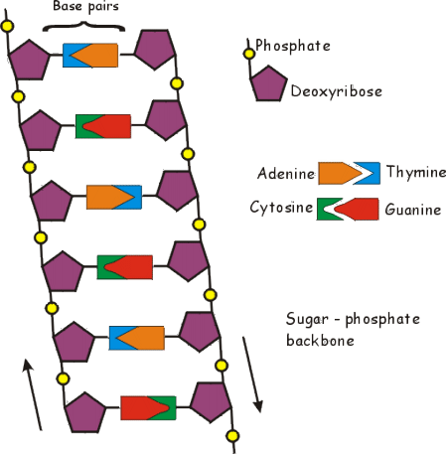

X

Y

a. Identify molecules X and Y.

b. The full molecule contains 8000 nucleotides, of which 20% contain adenine. What **number** of nucleotides in the molecule contain guanine?

**Key Area 1b: Replication of DNA**

1. The diagram below shows a molecule of DNA in the process of replication.

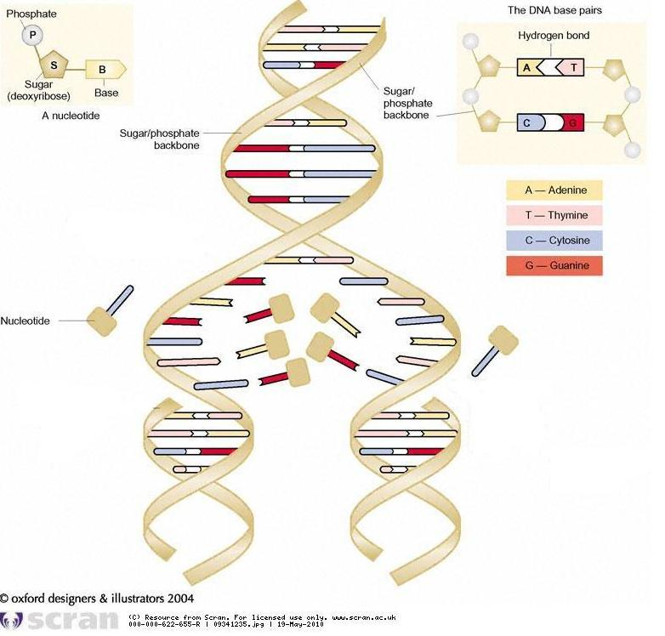

Describe the stages that happen when a DNA molecule replicates.

2. The following questions are taken from recent past papers, and refer to PCR.



b.

c.



a

d.. Describe an **application** of PCR.

**Key Area 2a: Gene Expression**

1a. Give 3 differences between DNA and RNA.

|  |  |
| --- | --- |
| **DNA** | **RNA** |
|  |  |
|  |  |
|  |  |

b. There are **three** types of RNA. Name each one, and give a brief description of its function.

2. Make a flow chart or summary diagram to describe the process of protein synthesis. Include:

* The names of the two main stages
* Colour coding for DNA, RNA and amino acids/polypeptides
* The location of each stage in the cell

3. The following question is taken from the 2013 Revised Higher Biology past paper.



4. Give **two** types of bond that are found in a protein molecule, and describe how each contributes to the structure of the protein.

5. The diagram shows the results of a chromatography experiment on some amino acids.

Distance moved by solvent front

Origin

B

A

Calculate the Rf values for amino acids A and B.

**Key Area 2b: Cellular Differentiation**

1. Complete the mind map below to describe the differences between meristems, embryonic and tissue stem cells.

2. The following question is taken from the 2012 Higher Biology past paper.

Processing

Selecting



3. The following question is taken from the 2012 Revised Higher Biology past paper.



4. Stem cell research can be controversial. Do **you** think that research using embryonic stem cells is acceptable? Try to give reasons.

**Key Area 3a: The Structure of the Genome**

1. What is meant by a “non-coding sequence”?

2. Give an example of a non-translated RNA molecule, and describe its function.

**Key Area 3b: Mutation**

1. The information below shows some possible mutations to a DNA sequence. (Taken from <http://en.wikipedia.org/> and modified under a Creative Commons licence).

Original sequence

Mutation D

Mutation C

Mutation B

Mutation A

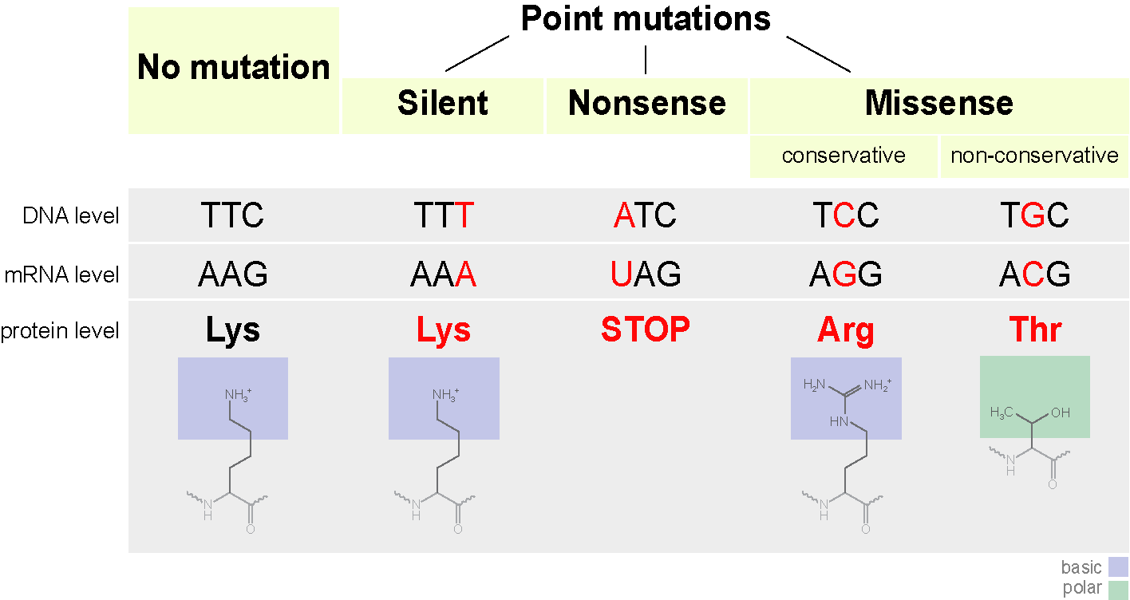

a. What category of mutations re these? Explain your reasoning.

b. Give the letter of the mutation that is a:

Missense mutation

Nonsense mutation

c. Another type of mutation is a **splice-site** mutation. Explain what is meant by this.

d. Why are mutations important in evolution?

2. The questions below are about chromosome mutations, and are taken from recent past papers.

b.

a.

**Key Area 3c: Evolution**

1. Explain the difference between **vertical** and **horizontal** gene transfer.

2. The male stag beetle’s “antlers” (actually enlarged mandibles) are thought to have arisen through **natural selection**.

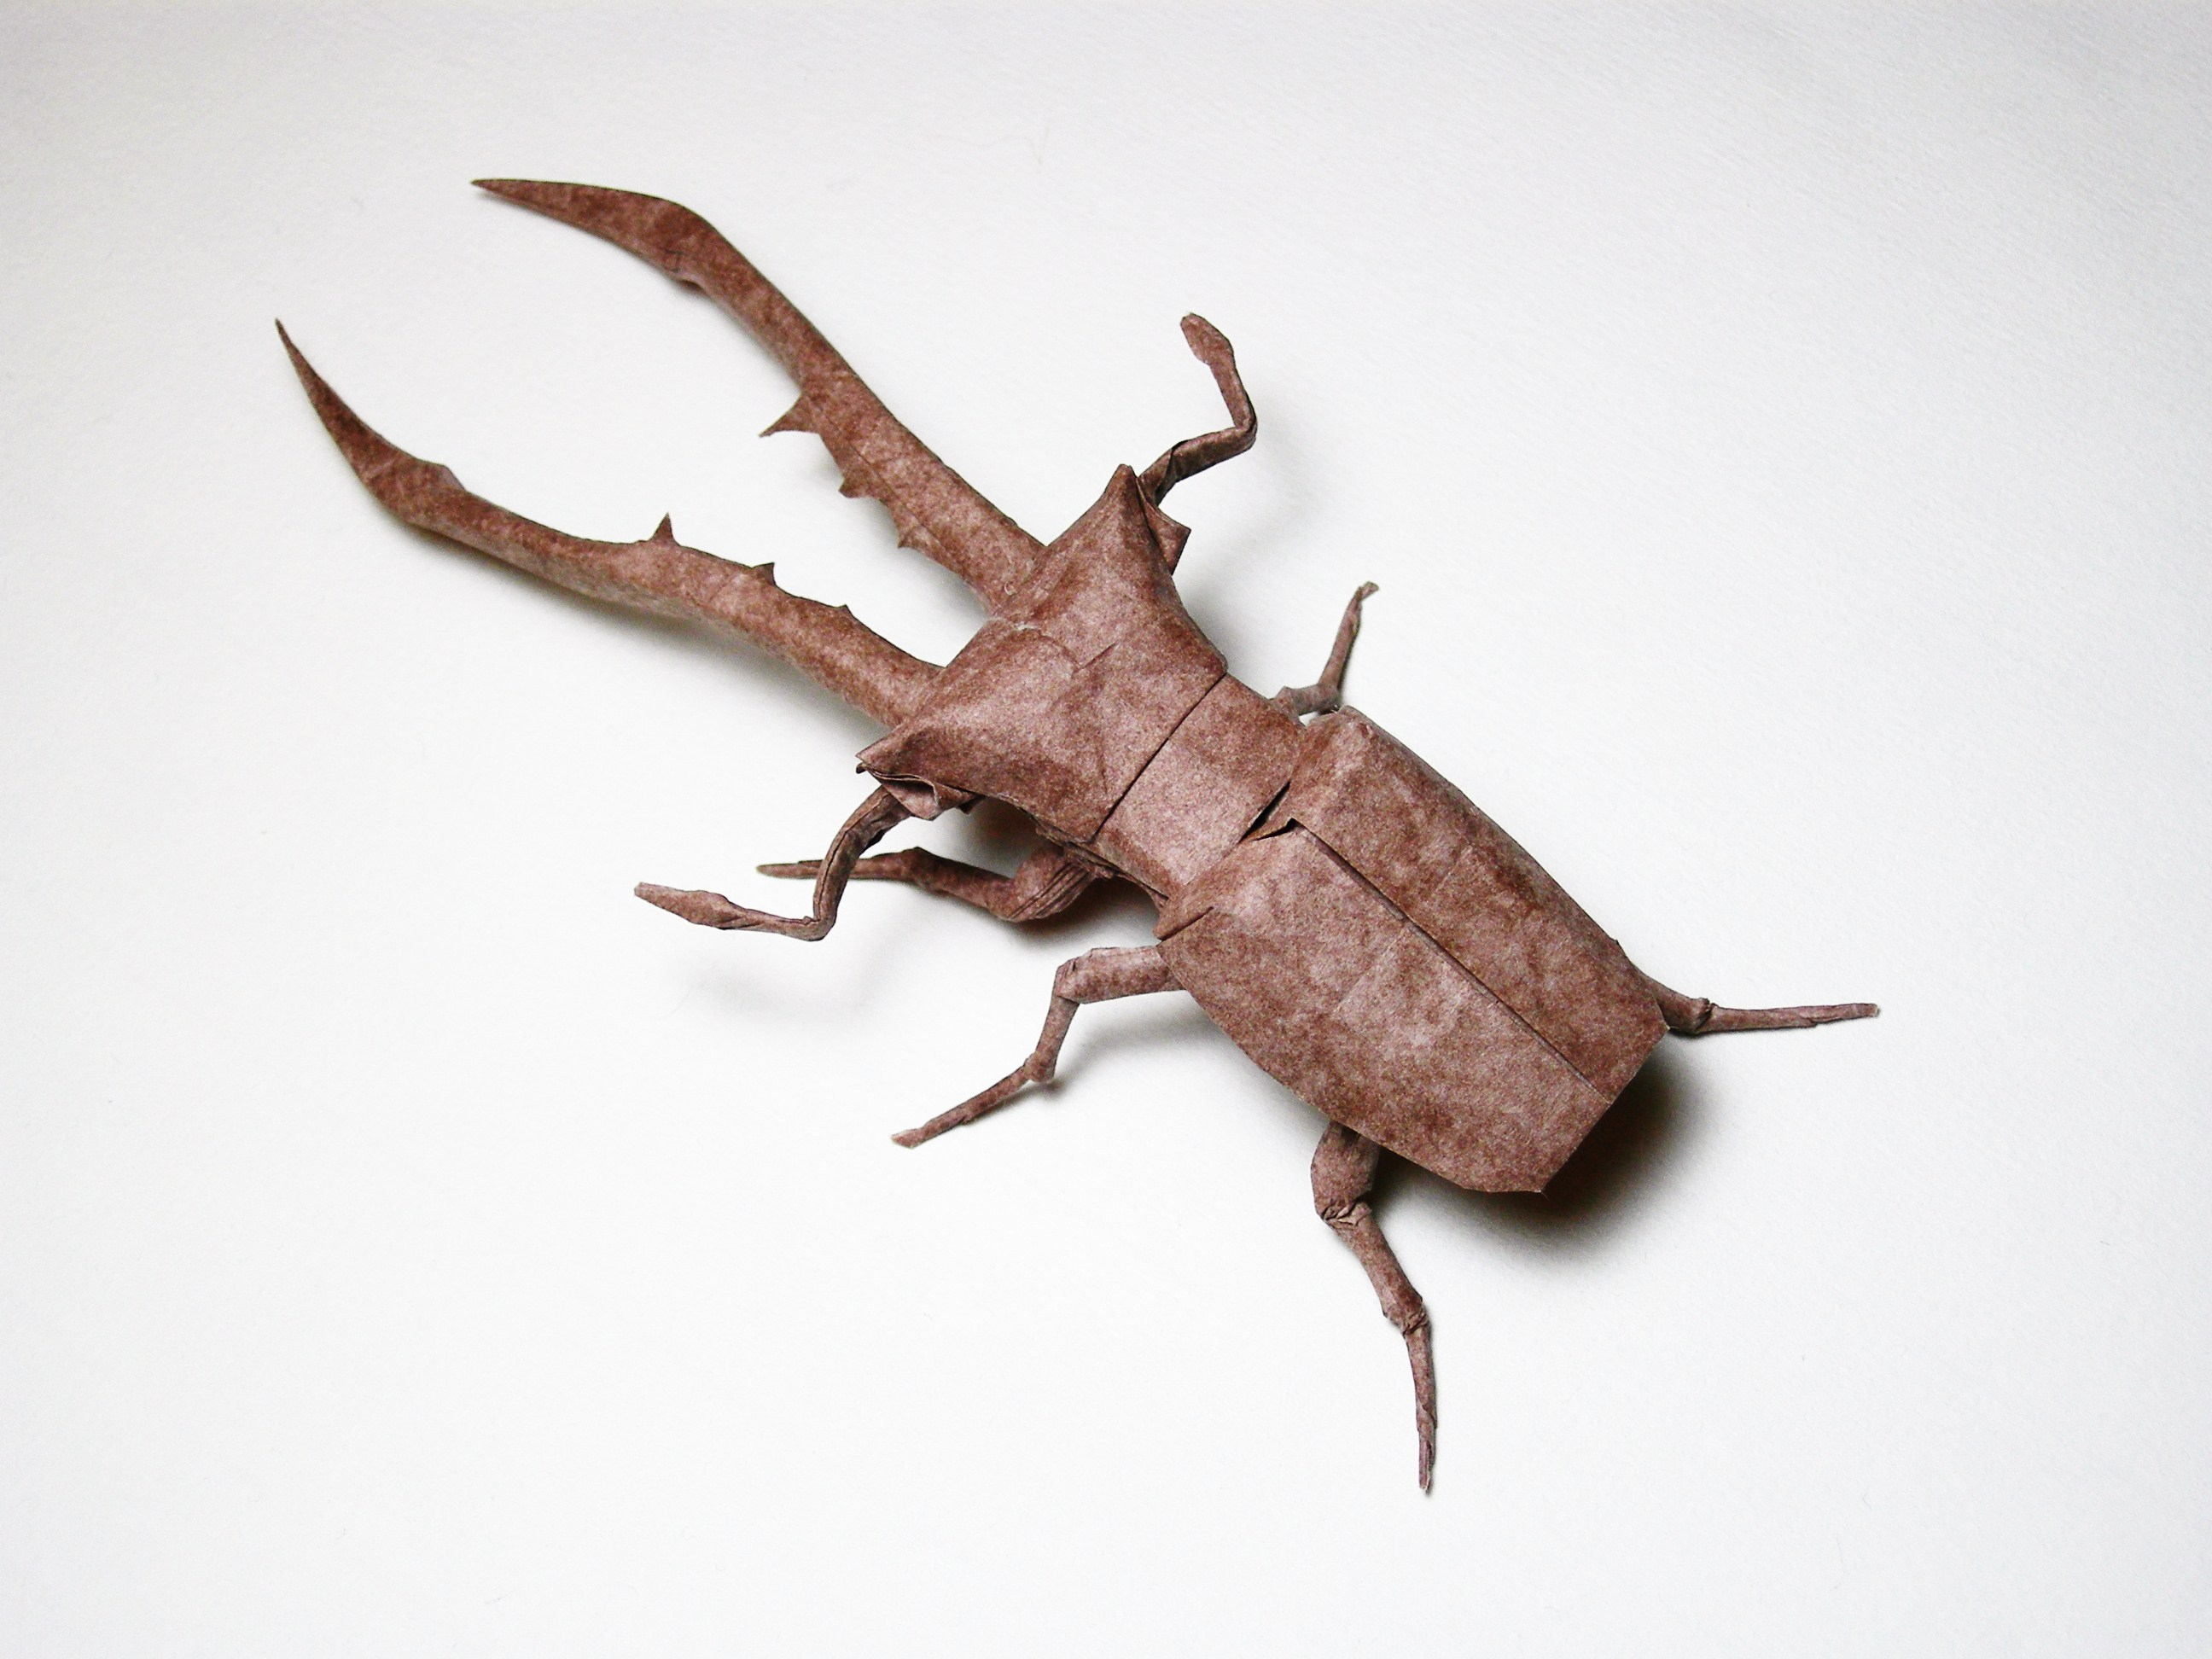

a. Describe how this trait could have evolved.

(Image taken from <http://www.flickr.com/photos/emraya/2898482458/> and used under a Creative Commons licence)

c. Give an example of another trait that has arisen through natural selection, and briefly describe how this occurred.

3. The following question is taken from the 2012 Higher Biology past paper.

Write notes on the following:

1. The Role of isolation and Mutation. (6)

2. Natural Selection. (4)

4. The following question is taken from the 2013 Revised Higher Biology past paper.



5. The following question is taken from the 2012 Higher Biology past paper.

Write notes on the following:

1. The Role of isolation and Mutation. (6)

2. Natural Selection. (4)

**Key Area 3d: Genomic Sequencing**

1a. The diagram shows a phylogenetic tree for some dinosaurs. (Taken from <http://en.wikipedia.org> and used under a Creative Commons licence).

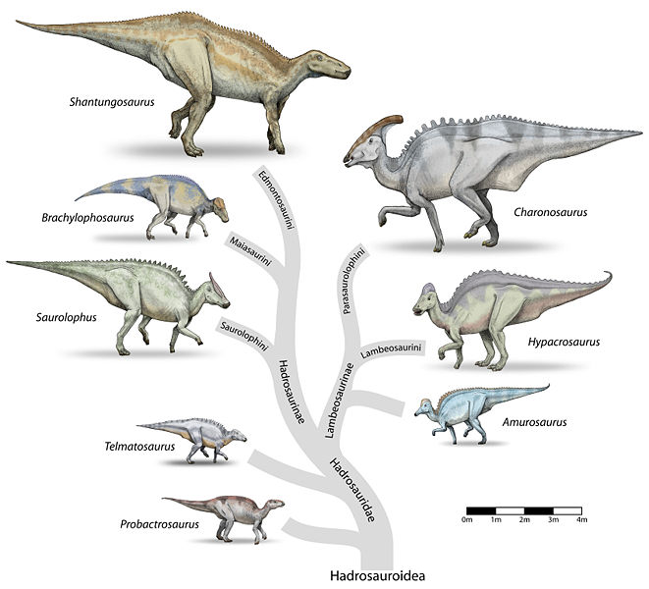

a. Explain how scientists use **mutations** and **molecular clocks** to put together such evolutionary trees.

b. Is *Telmatosaurus* more closely related to *Amurosaurus* or *Brachylophasaurus*? Explain your answer.

c. What other evidence do scientists use to determine the sequence of evolutionary events?

2. The following question is taken from the 2013 Revised Higher Biology past paper.



3. The following information, about the cancer treatment Herceptin, is taken from <http://www.nhs.uk/Conditions/Herceptin/Pages/Introduction.aspx>.

Herceptin is only recommended for people whose cancer is associated with a protein called human epidermal growth factor receptor 2 (HER2). These are known as HER2-positive cancers.

It is estimated that around one in five cases of breast cancer and stomach cancer are HER2-positive.

HER2 is present in all human cells, but in cases of HER2-positive cancers the levels are unusually high.

High levels of HER2 are known to stimulate the growth of these types of cancer, so Herceptin works by blocking the effects of the protein. At the same time it encourages the immune system (the body’s defense against infection) to attack the abnormal cells.

a. Why is Herceptin an example of **personalised medicine?**

b. Describe what is meant by **personal genomics** and explain how it could help ensure that Herceptin is prescribed to the correct people.