S3 Biology – Biotechnology HW 1 Enzymes and Fruit Juice extraction

Number
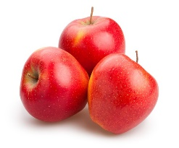
The method for an investigation into the effect of enzymes on fruit juice extraction is shown below.
METHOD

Chop the apples into cubes that are roughly 5 mm on a side. (Use care with the knife!)
- Use the balance to weigh 50g of chopped apple into 3 different beakers.
- Add the pectinase/amylase/cellulase enzyme separately, one in each beaker. Label the beakers accordingly.
- Stir the chopped apple pieces in each beaker with a separate plastic spoon. Cover the beakers with plastic wrap.
- Put beakers into water bath at 35ºC for 2 hrs.
- After removing beakers from the water bath use a separate plastic spoon to gently stir/squeeze the apple pieces in each.
- Place filter paper in funnels to filter the juice from the apple preparations into labelled measuring cylinders.
Answer these questions
- What is the input (independent) variable in this experiment?
- What is the output (dependent) variable in this experiment?
- What is the main hazard in this experiment and state the suggested safety precaution?
- When stirring the apple and enzyme mixture why is it necessary to use separate spoons?
- Name three variables that must be kept constant and are mentioned in the method.
- Name another variable that must be kept constant which is not mentioned in the method.
- Look at the results table below
Enzyme | Volume of juice extracted (ml)
pectinase | 22
amylase | 17.2
cellulase | 19.2
What conclusions can you draw from these results?

