S2 Bio BS Homework 2 Skeletal Muscles and Breathing

DO NOT write on these sheets Number ______

1. Name the three functions of the human skeleton.

2. The diagram below shows some of the structures in a human arm.

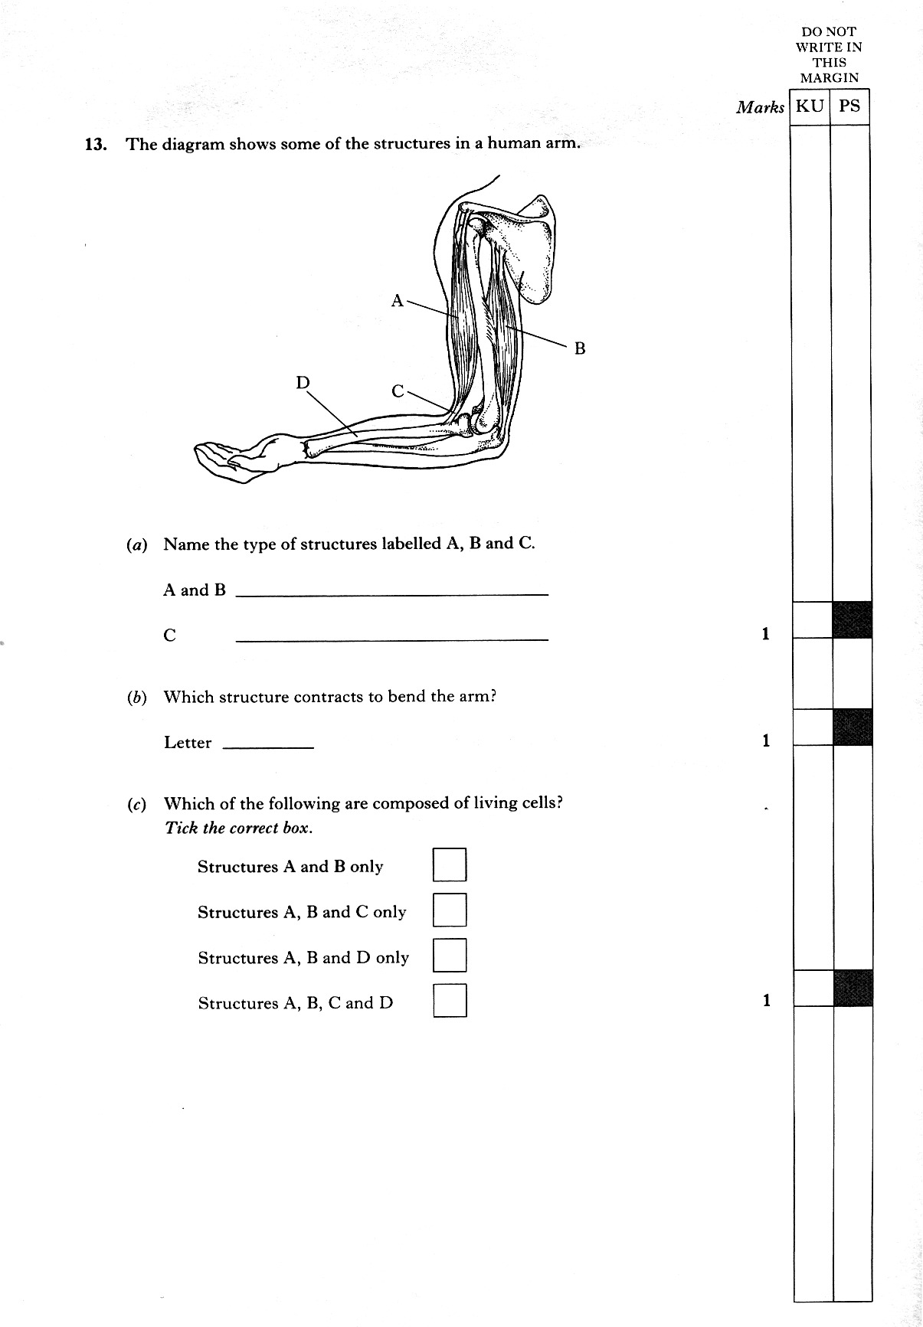a) Name the structures labelled A and B.

b) Which structure contracts to bend the arm?

c) Name the type of structure labelled C.

d) What type of joint is the elbow?

3. Bone is made up of two main components – flexible protein fibres and hard minerals. The flexible protein fibres can be removed by roasting the bone.

A weighed piece of dried bone was roasted for 30 minutes then reweighed. The results are shown below.

|  |  |
| --- | --- |
| mass of bone before roasting (g) | mass of bone after roasting (g) |
| 125 | 80 |

a) What percentage of the bone was made of protein fibres?

[Remember % = part / total x100]

b) How could the results of this investigation be made more reliable?

4. This diagram shows the lower leg of a person on tip toe.

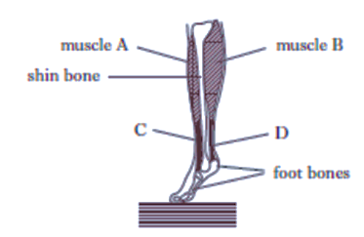a) Which structure must contract to achieve this position?

b) What feature of muscles means an antagonistic pair of muscles is needed for movement of a joint?

5. The diagram below shows some structures of the human lungs.



air sacs

Flow chart

a) Copy the flow chart and complete the names of the structures to give the pathway of air from X to the air sacs.

b) Name the process by which oxygen moves from the lungs into the blood.

c) Name the gas that moves in the opposite direction.

6. Which of the following are involved in **breathing out** during deep breathing in humans? **State the letter of each correct statement**.

1. diaphragm contracts
2. diaphragm relaxes
3. muscles between the ribs contract
4. muscles between the ribs relax
5. rib cage moves up and out
6. rib cage moves down and in

7. The pie charts below show the composition of **fresh air** and **breathed air**.

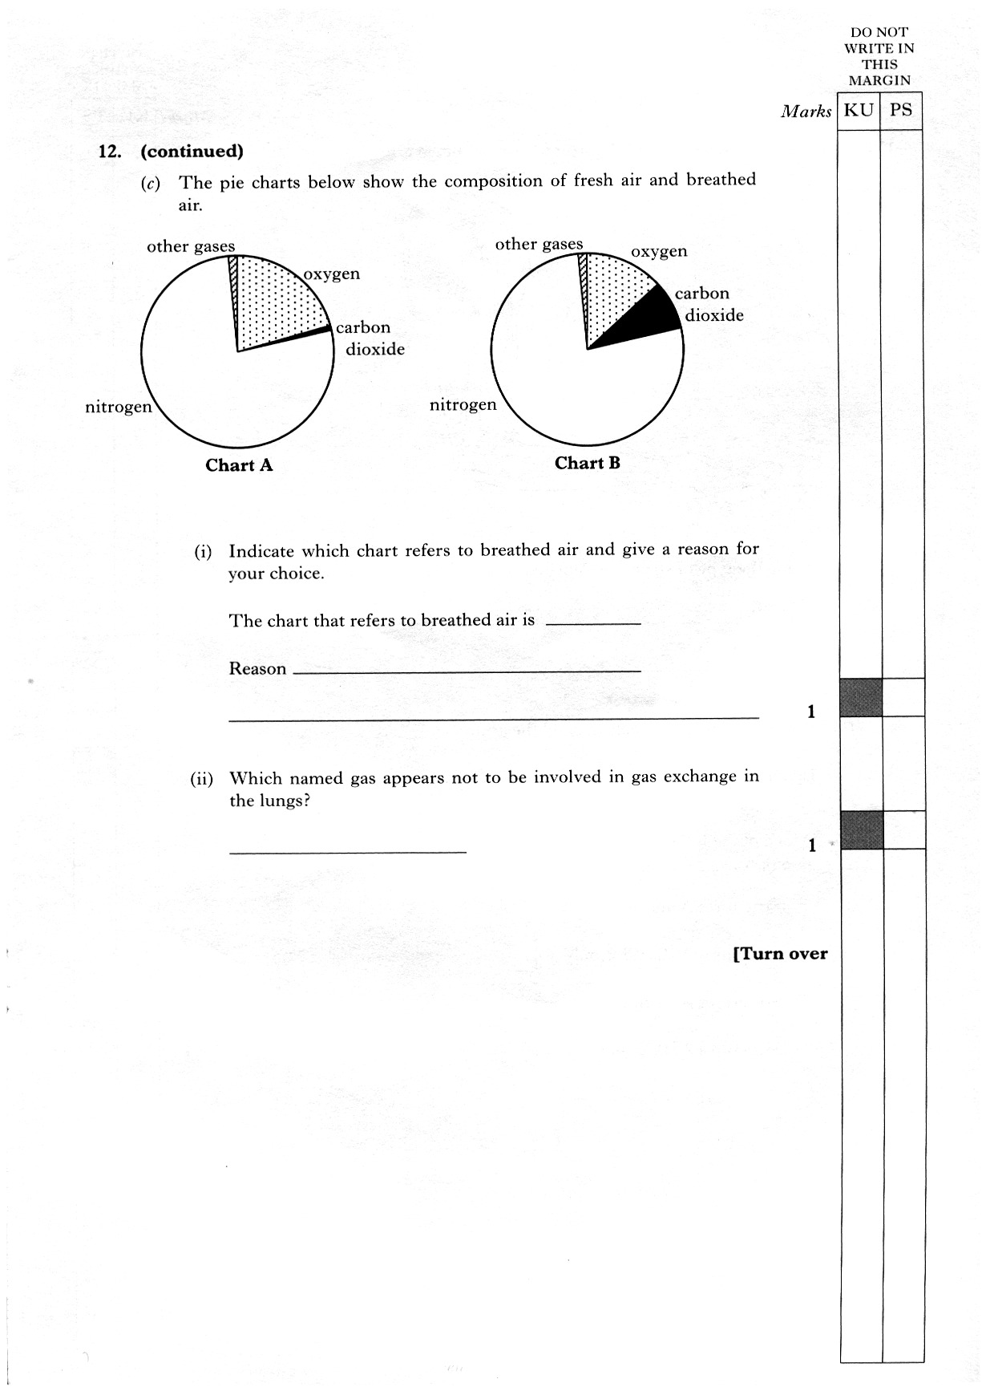a) Which chart refers to **breathed** **air**? Give a reason for your answer.

b) Which named gas seems not to be involved in gas exchange in the lungs?