S2 Biology Peebles High School

booklet number

always take the booklet with your number on it

you are responsible for this booklet in class

Body Systems

Pupil Booklet

[](http://www.mystshopper.com/blog) read information [http://t0.gstatic.com/images?q=tbn:ANd9GcTytTalOAoKypPWp3ziPjNrzU0x4SxsZZpxFg7SYsVUKyekU-XDp4__JQ:i0.wp.com/illustrationstock.net/wp-content/uploads/2015/04/thinking-clipart-yco6jdkcE.png%3Fresize%3D50%252C50](http://www.google.co.uk/url?q=http://illustrationstock.net/palm-tree/&sa=U&ei=2eIwVZmXE8vhaqiogPAF&ved=0CB4Q9QEwAw&usg=AFQjCNErBTtGpfJtj4q2T5H9rvC3wTMQdQ) think

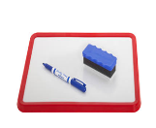 mini white board activity work sheet

[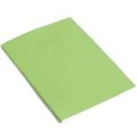](http://www.google.co.uk/url?q=http://www.rhinostationery.com/pack-of-20-rhino-a4-exercise-book-80-page-light-green-f6m/&sa=U&ei=xd4wVYqvOcm2abH0gegL&ved=0CBYQ9QEwAA&usg=AFQjCNFzzM3djH9c-l0kMAFETBmfWvvPAg)work in your jotter 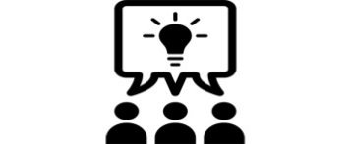group work

[](http://www.google.co.uk/url?q=http://findicons.com/icon/24960/highlighter_yellow_01&sa=U&ei=xOcwVaCqItjiasHygagE&ved=0CDwQ9QEwEg&usg=AFQjCNFpsXWVQOg-ovDcvsZA0dSkJYiktg)Highlight

Underlined Headings should be written into your jotter with the date

 ICT [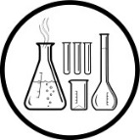](http://www.clipartpanda.com/clipart_images/vector-chemical-test-tubes-34003632)Practical work [](http://findicons.com/icon/158565/home?id=360421)Homework

Muscles

“Magnificent Muscles”

Each person should collect a mini whiteboard, pen and **1 Question card**.

You will also need a calculator.

Collect **10 responses** to your question from your

classmates,

then calculate the **average** response.

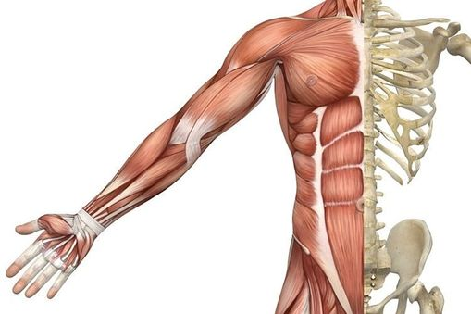Skeletal Muscles

[](http://www.mystshopper.com/blog)These are the muscles attached to the **skeleton**. Their function is **MOVEMENT**. As well as muscle attachment, the skeleton has two other **functions**

- **SUPPORT** the body keeping it upright

- **PROTECTION** of vital organs

Twig film – skeleton [2min24s] <https://www.twigonglow.com/film/bones-990/>

Your teacher may show you the model skeleton, can you name some of the main bones?

[](http://www.google.co.uk/url?q=http://www.rhinostationery.com/pack-of-20-rhino-a4-exercise-book-80-page-light-green-f6m/&sa=U&ei=xd4wVYqvOcm2abH0gegL&ved=0CBYQ9QEwAA&usg=AFQjCNFzzM3djH9c-l0kMAFETBmfWvvPAg)Collect a diagram of the skeleton and label it.

Remember to add a key to your diagram

Using three different colours shade in

* some bones whose role is **protection**,
* some bones whose role is **movement** and

|  |  |  |
| --- | --- | --- |
| **protection** | **movement** | **support** |
|  | Examples of bones |  |

* some bones whose role is to **support** the body

Present this information as a table

Antagonistic Pair of Muscles

[](http://www.mystshopper.com/blog)When a muscle is stimulated by an electrical impulse from a nerve it **contracts** (get shorter and fatter). When a muscle **relaxes** it cannot go back to its original length unless pulled. Because of this skeletal muscles must work in **pairs**, and because the pair of muscles bring about opposing movements they are called **antagonistic.**

Look at the diagram of the arm.

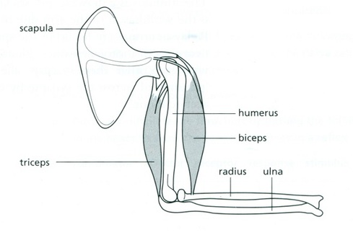

tendon

tendon

tendon

tendon

* The **biceps** is attached to the scapula (shoulder blade) and the radius by tendons.
* Contraction of the biceps pulls on the radius, moving the lower arm toward the scapula.
* This results in the arm bending (flexing) at the elbow - the arm is raised.
* The **triceps** is attached to the scapula, humerus and ulna by tendons.
* Contraction of the triceps pulls on the ulna, straightening (extending) the arm.
* In doing so, the triceps pulls the biceps back to its original length.

Muscles can only pull, they cannot push

[](http://www.google.co.uk/url?q=http://www.rhinostationery.com/pack-of-20-rhino-a4-exercise-book-80-page-light-green-f6m/&sa=U&ei=xd4wVYqvOcm2abH0gegL&ved=0CBYQ9QEwAA&usg=AFQjCNFzzM3djH9c-l0kMAFETBmfWvvPAg)Collect the D**iagram of the Arm** showing these antagonistic muscles.

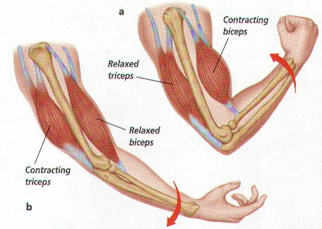Use the two arm diagrams in this booklet to **label** it, then **stick** it into your jotter and **copy and complete** the following table below it.

|  |  |
| --- | --- |
| muscle | position of arm when contracted |
| biceps |  |
| triceps |  |

Twig film – Skeletal muscles

<https://www.twigonglow.com/film/skeletal-muscles-996/>

**Answer the following question in full sentences in your jotter.**

The figure below is a simplified diagram of the muscles and bones of the human leg.

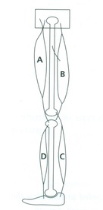a) Copy and complete the following sentences.   
Muscles are formed from cells which have special property of being able to c____________ when stimulated by electrical signals from nerves . Because of this, muscles cannot push, they can only p_______.

b) Muscles operate as a______________ p__________.   
  
c) i) Which muscles **A, B, C** or **D**, must contract in order to raise the heel to stand on tiptoe?   
   ii) Which muscles **A, B, C** or **D**, must contract to bend the leg at the knee?

iii) What would happen to the foot if muscle D contracted?

iv)What would happen to the leg if muscle A contracted?

d) When running very quickly, the muscles of the leg may not receive sufficient oxygen to supply all their energy requirements. i) Name the type of respiration these muscle cells carry out to release additional energy.

ii) Name the waste product produced by this process.   
 [](http://www.google.co.uk/url?q=http://www.rhinostationery.com/pack-of-20-rhino-a4-exercise-book-80-page-light-green-f6m/&sa=U&ei=xd4wVYqvOcm2abH0gegL&ved=0CBYQ9QEwAA&usg=AFQjCNFzzM3djH9c-l0kMAFETBmfWvvPAg)update your Glossary

[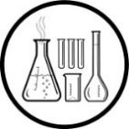](http://www.clipartpanda.com/clipart_images/vector-chemical-test-tubes-34003632)**Biceps Curl-Force Investigation** The arm is an example of a lever, in which the elbow is a hinge. The elbow, like the knee, is called a **hinge joint.**

**AIM** Using two pieces of wood joined by a hinge, find out about the forces in the arm.

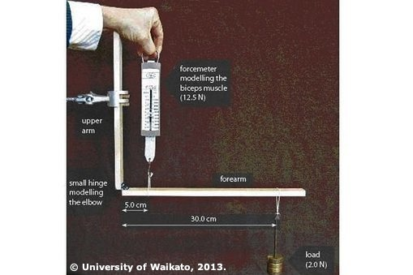

Force meter modelling the effort from the biceps muscle

Upper arm

Forearm

Load modelling and object being carried

Small hinge modelling the elbow

**Collect**

* Clamp stand
* 20 N force meter
* 3 x 50 g masses (or similar) & 1 x 50 g mass hanger
* String
* 2 lengths of thin wood (25 cm and 35 cm) joined by a hinge to form an L shape

**Method**

1. Assemble the lever system as shown in the photo. Clamp vertically the length of wood that models the upper arm.
2. Hang a 50 g mass 30 cm from the hinge. This models a load held in the hand.
3. Pull vertically up on the force meter, which is attached 5 cm from the hinge (elbow). The force meter models the biceps muscle.
4. Record the reading on the force meter when it lifts the forearm length of wood to a horizontal position off the bench. The 50 g mass produces a load of 0.5N.  
    weight (N) = mass (**kg**) x 10

= 0.050 **kg** x 10

[](http://www.google.co.uk/url?q=http://www.rhinostationery.com/pack-of-20-rhino-a4-exercise-book-80-page-light-green-f6m/&sa=U&ei=xd4wVYqvOcm2abH0gegL&ved=0CBYQ9QEwAA&usg=AFQjCNFzzM3djH9c-l0kMAFETBmfWvvPAg) = 0.5 N

1. Repeat step 4 for 100 g (**1.0N**), 150 g (**1.5N**) and 200 g **(2.0N**)
2. Record **RESULTS\*** in a table & write your **CONCLUSION.**

|  |  |
| --- | --- |
| Load on Arm **(N)** | Force to lift Bicep (N) |
|  |  |

*If you have time repeat the experiment or collect results from another group & calculate the averages.

[](http://www.clipartpanda.com/clipart_images/vector-chemical-test-tubes-34003632)**Chicken Wing dissection**

A chicken wing is similar in construction to the human arm. In this dissection, you will locate & describe the various tissues and structures of the wing of a chicken.

***Safety***

* Wear gloves.
* Don’t do any ‘hand to mouth’ activities (putting a pen in your mouth, chewing gum)
* Wash your hands at the end of the dissection with plenty of antibacterial soap and hot water.
* Dry your hands thoroughly afterwards.
* Wipe surfaces with antibacterial spray.
* **CAUTION: Scalpels are very sharp. Use extreme care. Only cut downwards and away from your body.**

***What to do***

1. Put on the disposable gloves.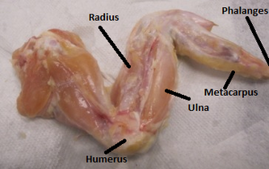 Place the chicken wing on a dissecting board.
2. Remove the skin. This will be tricky but persevere.
3. It should look similar to the picture on the right. You can now see the **muscle – the ‘meat’**. Muscles work in bundles. Examine the muscle and separate the bundles of muscles with your fingers. Begin the dissection by inserting your thumb into the muscle of the lower arm. You will need to push quite hard through the shiny lining (called fascia) that is over the muscle, but it will give way at the natural separations between the muscle bundles. Continue separating the muscle into bundles by forcing your thumb and fingers through the muscle until you are able to see several separate bundles.
4. At both ends of the muscles, you will see the strong, white cords, called **tendons**. These hold the muscle to the bones.
5. Also look for **nerves**. Nerves are generally thin, threadlike white strands found between the muscle and the nearest bone.
6. Find the **bicep muscle and pull on it**, this is like the bicep contracting and should result in the wing bending
7. Find the **triceps muscle and pull on it**, this is like the triceps contracting and should result in the wing straightening
8. Take a look at the bones. Look at the shapes of the ends of the bones and how they fit together. The bones can move in one direction (plane) but not in any other – like a door on a door hinge. This is a **hinge joint**.
9. Dispose of the chicken in a plastic bag. Make sure to clean up and wash your hands thoroughly with plenty of antibacterial soap and water. Wipe down all surrounding surfaces.

Breathing Muscles

On a mini whiteboard write the equation for the process in muscles that releases the energy from food (hint…its **respiration**!). Circle the two gases involved.

[](http://www.mystshopper.com/blog)

Breathing makes air to flow in and out of the lungs and allows the body to get rid of the waste product **carbon dioxide** and get the raw material **oxygen** into the blood. The movements of two different muscle groups make breathing happen to allow **gas exchange**. Breathing **in** is called **inhalation**, breathing **out** is called **exhalation**.

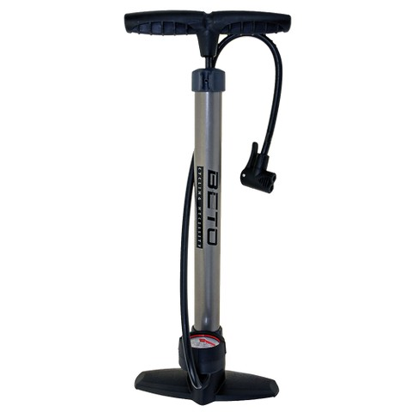

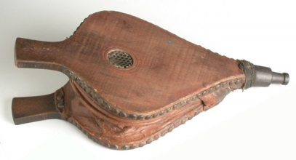[http://t0.gstatic.com/images?q=tbn:ANd9GcTytTalOAoKypPWp3ziPjNrzU0x4SxsZZpxFg7SYsVUKyekU-XDp4__JQ:i0.wp.com/illustrationstock.net/wp-content/uploads/2015/04/thinking-clipart-yco6jdkcE.png%3Fresize%3D50%252C50](http://www.google.co.uk/url?q=http://illustrationstock.net/palm-tree/&sa=U&ei=2eIwVZmXE8vhaqiogPAF&ved=0CB4Q9QEwAw&usg=AFQjCNErBTtGpfJtj4q2T5H9rvC3wTMQdQ)Look at these two pieces of equipment.

What are they used for?

What do they have in common?

How are they like the lungs?

Bellows

Bike pump



Your teacher may show you the breathing animation. <http://www.footprints-science.co.uk/flash/Breathing.swf>

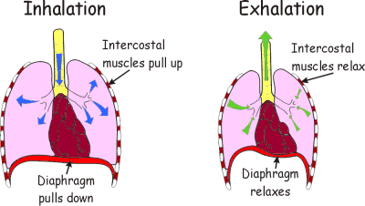

Look at the statements below; on a mini whiteboard arrange them in the correct order for **inhaling** then **exhaling**.

1. Chest volume increases
2. Diaphragm contracts and flattens, ribs move up and out
3. Chest volume decreases
4. Air is drawn into the lungs
5. Air is pushed out of the lungs
6. Diaphragm relaxes and moves up, ribs move down and in

[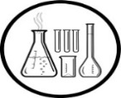](http://www.clipartpanda.com/clipart_images/vector-chemical-test-tubes-34003632)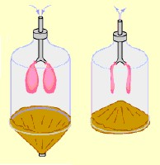

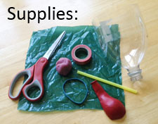Your teacher may show you the model lungs.

Can you make an improved version with a moving ribcage?

Twig film on the lungs

<https://www.twigonglow.com/film/factpack-lungs-982/>

[](http://www.google.co.uk/url?q=http://www.rhinostationery.com/pack-of-20-rhino-a4-exercise-book-80-page-light-green-f6m/&sa=U&ei=xd4wVYqvOcm2abH0gegL&ved=0CBYQ9QEwAA&usg=AFQjCNFzzM3djH9c-l0kMAFETBmfWvvPAg)Draw a simple, labelled diagram and use the statement in the box above to explain how the **intercostal muscles** and **diaphragm** bring about breathing. [Extension Task – write a description of how your model can be used to explain breathing movements]

Respiratory System

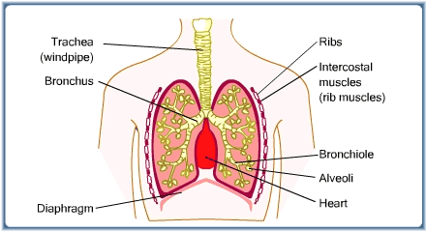

Air Sac

Match each of the following descriptions to one part of the respiratory system shown in the diagram above

1. a sheet of muscle below the lungs
2. the airway that brings air to and from the lungs
3. the tiny branched airways in the lungs
4. the muscles that move the ribs
5. one of the two airways that split from the trachea (windpipe)
6. the end of every bronchiole, where gas exchange take place (CO2 diffuses from the blood to the air, O2 diffuses from the air to the blood)

[](http://www.google.co.uk/url?q=http://www.rhinostationery.com/pack-of-20-rhino-a4-exercise-book-80-page-light-green-f6m/&sa=U&ei=xd4wVYqvOcm2abH0gegL&ved=0CBYQ9QEwAA&usg=AFQjCNFzzM3djH9c-l0kMAFETBmfWvvPAg) Collect the **Respiratory System Diagram**, **label** it, then **stick** it into your jotter and make a **part and function** table below it. Use your knowledge of **diffusion** [from the Cells unit] to explain why the CO2 and O2 move in the direction shown on the air sac diagram.

[](http://www.google.co.uk/url?q=http://www.rhinostationery.com/pack-of-20-rhino-a4-exercise-book-80-page-light-green-f6m/&sa=U&ei=xd4wVYqvOcm2abH0gegL&ved=0CBYQ9QEwAA&usg=AFQjCNFzzM3djH9c-l0kMAFETBmfWvvPAg)update your Glossary

Cardiac Muscle

[](http://www.mystshopper.com/blog)**Cardiac** muscle is a specialised muscle found only within the heart.

It is an involuntary muscle. This means it will contract and relax without your conscious control – just as well!

Cardiac muscle is specialised for its role in another way. Skeletal muscle will fatigue if it contracts repeatedly without rest. Remember the peg experiment? Cardiac muscle is different from skeletal muscle because it does not tire – again, just as well!

The heart is essentially a **muscular pump.** It keeps the blood moving through the body. The average person’s heart beats more than 4,000 times in an hour (figuring on an average of 70 beats per minute), so, by time you turn 70, your heart will beat some two-and-a-half billion times.

 Twig films about the heart

<https://www.twigonglow.com/film/heart-976/>

<https://www.twigonglow.com/experiment/dissection-heart-4179/>

Circulatory System

Collect the **Circulatory System** **diagram** and stick it into your jotter.

Collect the **Circulatory** **System Sequence** **Cards.** Use the information from your diagram and any classroom resources to put the parts of the circulatory system in the right order showing the journey that blood makes as it moves round the body.

[](http://www.google.co.uk/url?q=http://www.rhinostationery.com/pack-of-20-rhino-a4-exercise-book-80-page-light-green-f6m/&sa=U&ei=xd4wVYqvOcm2abH0gegL&ved=0CBYQ9QEwAA&usg=AFQjCNFzzM3djH9c-l0kMAFETBmfWvvPAg)Use the information on the diagram and any classroom resources to **copy and complete** the following paragraph.

The heart is made up of _________ chambers. The two at the top are called ______________. The two at the bottom are called ____________.

Blood flows into the right atrium from the main vein called the ____________. The right atrium pumps this blood into the ________________. When the right ventricle contracts blood is pumped up to the ________________. This blood travels to the lungs where it gets rid of its _____________________ and collects ______________. The ____________________ takes the blood back to the heart, where it enters the __________________. When the left atrium contracts it squeezes blood down into the __________________.

This blood is now pumped into the aorta where it will travel to all parts of the body. The body tissues use up the ________________ in the blood and get rid of their _____________________. The veins converge into the _____________ and the blood is taken back to the heart. Arteries take blood __________ from the heart and _________________ bring blood back to the heart.

When the blood moves from the atria to the ventricles it passes through a ______________. There are also _______ in the pulmonary artery and aorta. Valves prevent the blood flowing backwards.

The muscle of the ____ ventricle is thicker than the ___ ventricle as the _____ must create enough force to pump the blood round the body. The right ventricle only pumps blood to the ________.

[](http://www.google.co.uk/url?q=http://www.rhinostationery.com/pack-of-20-rhino-a4-exercise-book-80-page-light-green-f6m/&sa=U&ei=xd4wVYqvOcm2abH0gegL&ved=0CBYQ9QEwAA&usg=AFQjCNFzzM3djH9c-l0kMAFETBmfWvvPAg)update your Glossary

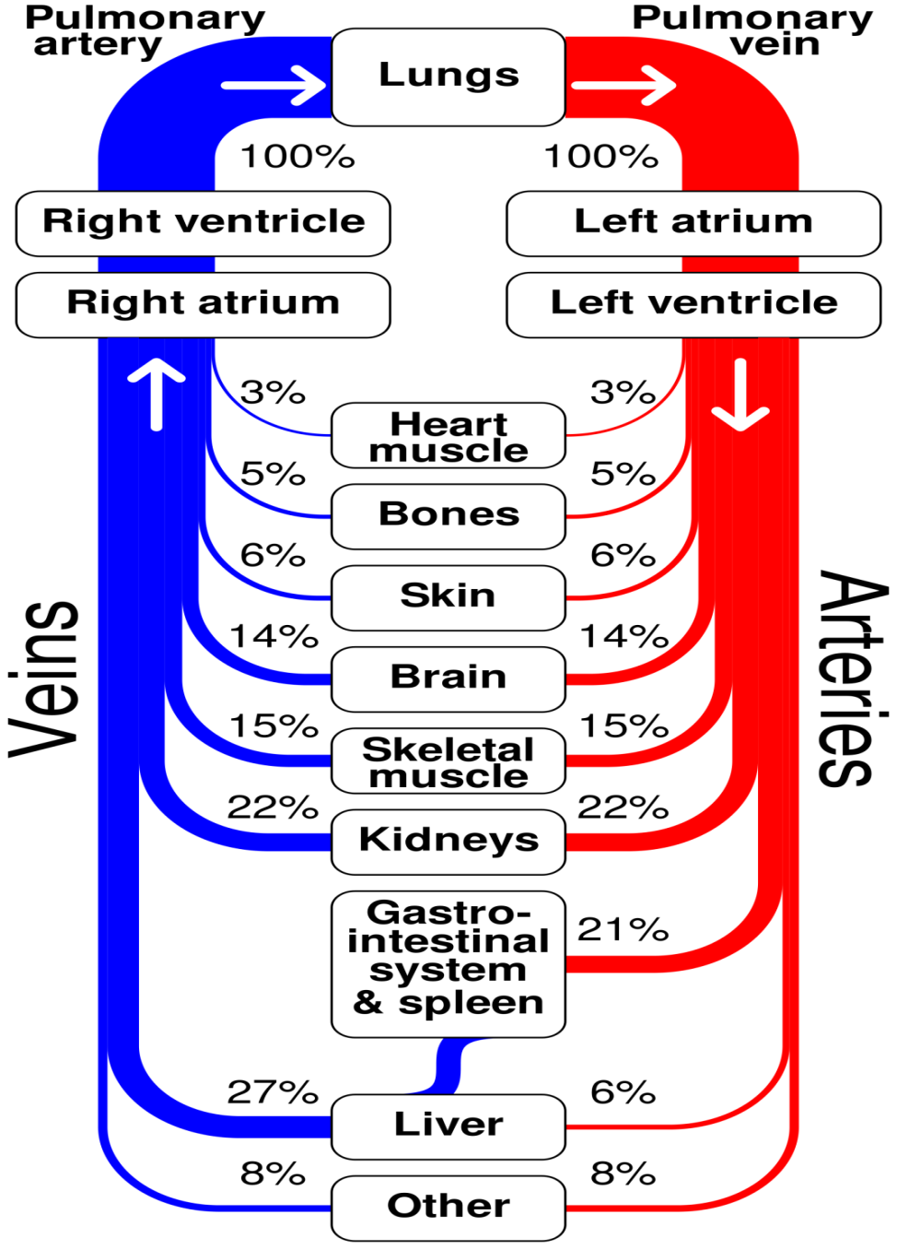Circulatory System Data Handling

[](http://www.google.co.uk/url?q=http://www.rhinostationery.com/pack-of-20-rhino-a4-exercise-book-80-page-light-green-f6m/&sa=U&ei=xd4wVYqvOcm2abH0gegL&ved=0CBYQ9QEwAA&usg=AFQjCNFzzM3djH9c-l0kMAFETBmfWvvPAg)Look at the diagram to the left and use it to complete the following tasks

* Draw a table showing the % of blood **delivered** to each organ / system in the body – put them in order from highest to lowest.
* Use this information to draw a **bar graph.**
* Answer the following questions.

1. After the lungs which organ receives the highest % of the blood supply?
2. How many times greater is the blood supply to the muscles compared to the bones?
3. Under what conditions would the blood supply to the skeletal muscles increase?
4. What other type of muscle receives a blood supply?
5. When comparing two values it can be useful to **calculate a ratio**.

Example – if a recipe needs 300g of flour and 150g of sugar we can say there is a ratio of 300:150 for flour to sugar, this is more useful we reduce it to its simplest form. To do this you divide the numbers in the ratio by a common factor.

300 and 150 have 150 as a **common factor**

300÷150 = 2, 150 ÷ 150 = 1 so the simple ratio of flour to sugar is 2:1

Express as a **ratio**, the % of blood **delivered** to **skeletal** muscle compared to **heart** muscle.

1. What is the name of the artery that supplies blood to the **heart** muscle? Use classroom resources to find out.

[](http://www.google.co.uk/url?q=http://www.rhinostationery.com/pack-of-20-rhino-a4-exercise-book-80-page-light-green-f6m/&sa=U&ei=xd4wVYqvOcm2abH0gegL&ved=0CBYQ9QEwAA&usg=AFQjCNFzzM3djH9c-l0kMAFETBmfWvvPAg)Homeostasis

Copy this sentence into your jotter

Homeostasis is the maintenance of a constant environment in the body.

There are many systems that contribute to homeostasis. You will learn about 2 (or 3) of these.

[](http://www.google.co.uk/url?q=http://www.rhinostationery.com/pack-of-20-rhino-a4-exercise-book-80-page-light-green-f6m/&sa=U&ei=xd4wVYqvOcm2abH0gegL&ved=0CBYQ9QEwAA&usg=AFQjCNFzzM3djH9c-l0kMAFETBmfWvvPAg)Blood Glucose Regulation

* Look at the diagram on the next page and use the information on it to answer the following questions.

Name the two **hormones** involved in keeping blood glucose at a normal level.

How does the **pancreas** respond to a decrease in the blood glucose level?

What effect does **glucagon** have on the liver?

How does the **pancreas** respond to an increase in the blood glucose level?

What are the two **target tissues** of insulin?

How does **insulin** cause a decrease in blood glucose level?

Give a reason why someone’s blood glucose level would

**Increase**

**Decrease**.

* Collect two coloured pencil/pens and copy the following summary diagram into your jotter

In the liver

& muscles

In the blood

INSULIN

GLUCAGON

Glucose

Glycogen

Carbohydrate

HORMONE made by the pancreas

[http://t0.gstatic.com/images?q=tbn:ANd9GcTytTalOAoKypPWp3ziPjNrzU0x4SxsZZpxFg7SYsVUKyekU-XDp4__JQ:i0.wp.com/illustrationstock.net/wp-content/uploads/2015/04/thinking-clipart-yco6jdkcE.png%3Fresize%3D50%252C50http://t0.gstatic.com/images?q=tbn:ANd9GcTytTalOAoKypPWp3ziPjNrzU0x4SxsZZpxFg7SYsVUKyekU-XDp4__JQ:i0.wp.com/illustrationstock.net/wp-content/uploads/2015/04/thinking-clipart-yco6jdkcE.png%3Fresize%3D50%252C50](http://www.google.co.uk/url?q=http://illustrationstock.net/palm-tree/&sa=U&ei=2eIwVZmXE8vhaqiogPAF&ved=0CB4Q9QEwAw&usg=AFQjCNErBTtGpfJtj4q2T5H9rvC3wTMQdQ)

When the GLUCose is GONe you need GLUCaGON

Blood Glucose Regulation

**Hormone**

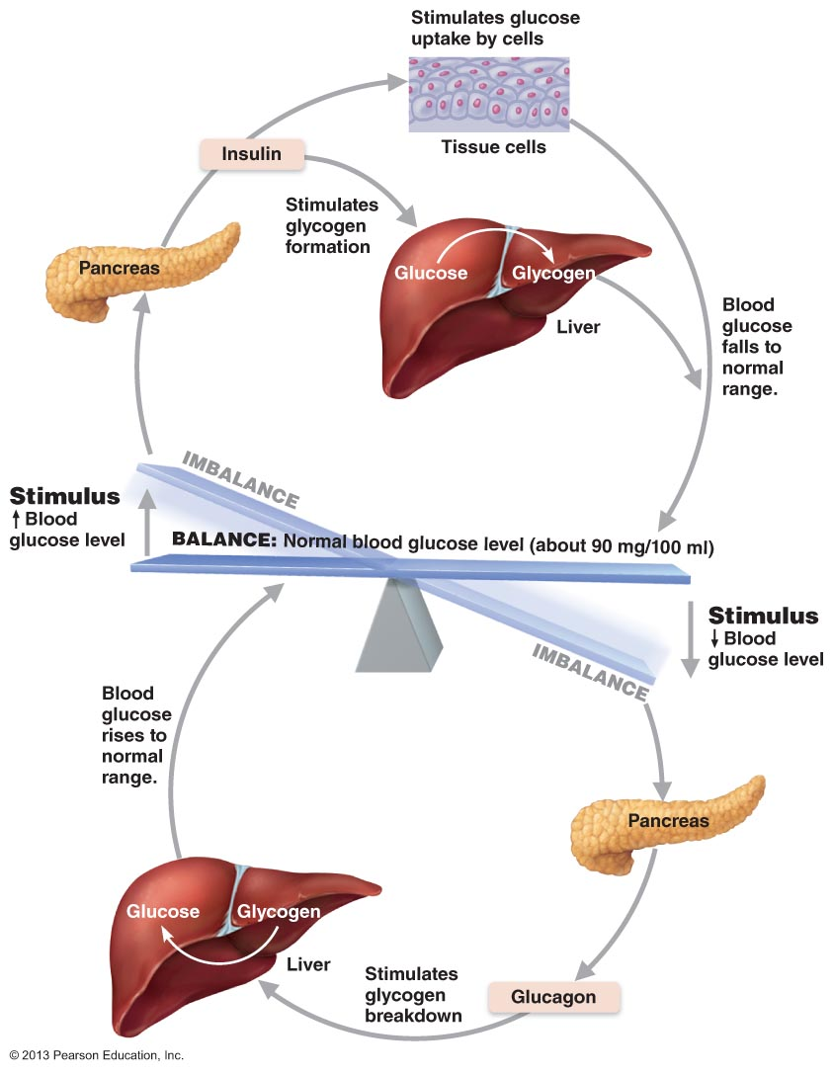

[](http://www.google.co.uk/url?q=http://www.rhinostationery.com/pack-of-20-rhino-a4-exercise-book-80-page-light-green-f6m/&sa=U&ei=xd4wVYqvOcm2abH0gegL&ved=0CBYQ9QEwAA&usg=AFQjCNFzzM3djH9c-l0kMAFETBmfWvvPAg)Blood Glucose Regulation Data handling

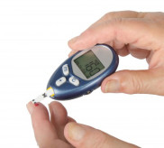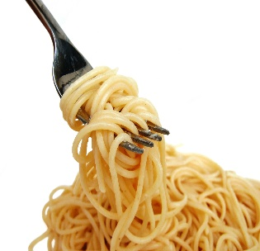**1.** A student ate a meal containing carbohydrates at 07:00. He ate nothing else for the next five hours and tested his blood every hour.

The table shows the concentration of glucose in his blood at hourly intervals after the meal.

|  |  |
| --- | --- |
| **Time of day** | **Concentration of Glucose in Blood**  **(mg per 100 cm3 of blood)** |
| 07:00 | 90 |
| 08:00 | 120 |
| 09:00 | 70 |
| 10:00 | 85 |
| 11:00 | 110 |
| 12:00 | 80 |

1. Present the results as a **line graph** (time of day on the x-axis) and stick it into your jotter after your teacher has checked it.
2. Explain the rise in the concentration of glucose between 07:00 and 08:00.
3. Calculate the **% increase** in concentration of glucose in the blood between 07.00 and 08.00. *[show your workings]*

**[CLUE- %CHANGE = CHANGE ÷ INITIAL VALUE X 100]**

1. The concentration of glucose in his blood fell between 08:00 and 09:00. **Explain** why this happened – HINT there are two factors involved.
2. **Describe** the role of hormones in the fluctuation of glucose concentration between 09:00 and 12:00.
3. Calculate the **average concentration** of glucose in blood over the 5 hour period. *[show your workings]*

Osmoregulation

[](http://www.mystshopper.com/blog)This means controlling the water content of the body and is done to protect cells by avoiding too much water entering or leaving them.

**Osmosis** is a special type of **diffusion**. It is the movement of water from an area of **high water concentration** to an area of **low water concentration** across a **selectively permeable membrane** (e.g. a cell membrane).

Example

The **red blood cells** have the vital job of carrying **oxygen** round the body. As with many aspects of Biology, the **shape** of a red blood cell plays an important role in its **function**. Movement of water by osmosis into or out of the red blood cell can change their shape and prevent them from doing their job – this would be a disaster!

See below-

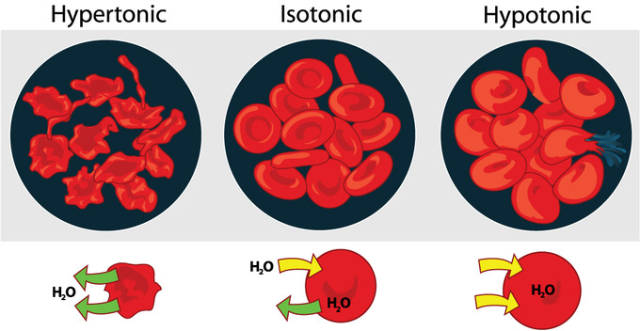In this situation the water concentration **inside** the cell is the **same** as the water concentration **outside** the cell. The water leaving is equal to the water entering so there is no overall gain or loss of water from these cells.

The shape is **not affected** and the red blood cells can perform their function.

However look what happens when the water concentration outside the cells is too….

**LOW** ….or too **HIGH**

Water moves **out** of the cells and they **shrivel up**.



Water moves **into** the cells and they swell up then **burst**.

It is therefore of vital importance that the level of water in the body is maintained at a constant level.

Human Urinary System

[](http://www.mystshopper.com/blog)The job of water balance in the body is performed by the **kidneys**. The kidneys are part of the **urinary system**. Look back at page 10 and you will see that the kidneys receive a high percentage of the blood volume. They not only regulate the water levels in the body but they also remove a **toxic waste** called **urea** from the blood. The components that are removed from the blood make up the liquid called **urine**. This liquid travels in tubes called **ureters** to the **bladder** where it is stored temporarily. When appropriate the urine will leave the body by travelling along the **urethra**.

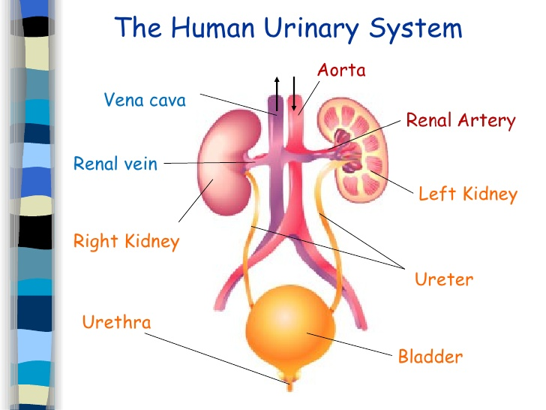

Mechanism of Urine Production

[](http://www.mystshopper.com/blog)When blood enters the kidney it passes through **tiny filtering units** that **remove** any **small molecules** including **water, glucose** and **urea.**

* The body needs to **get rid** ofthe **urea** so this is good.
* The body **needs** glucose so ALL of the **glucose** filtered out of the blood is **reabsorbed** back into it.
* The body **may or may not want to lose water** depending on the internal conditions. So a message must be sent to the kidneys. This message is sent in the form of a **hormone** called **ADH** (anti-diuretic hormone). ADH is made by a **gland** in the brain and targets the tiny filtering units. The **more** ADH released the **more water reabsorbed** and the **less water lost in the urine**.

Twig film on the Kidneys

<https://www.twigonglow.com/film/kidneys-1016/>

This information is summarised in the diagram below. Start in the middle and follow the arrows round in one direction and then the other.

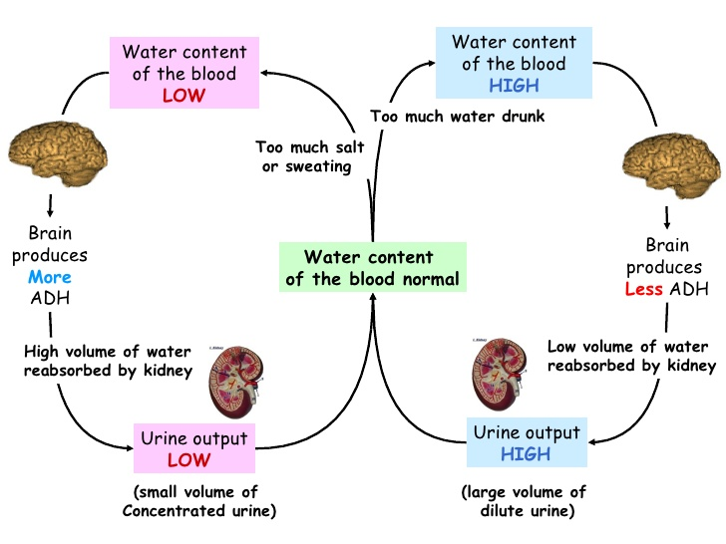

[](http://www.google.co.uk/url?q=http://www.rhinostationery.com/pack-of-20-rhino-a4-exercise-book-80-page-light-green-f6m/&sa=U&ei=xd4wVYqvOcm2abH0gegL&ved=0CBYQ9QEwAA&usg=AFQjCNFzzM3djH9c-l0kMAFETBmfWvvPAg) Collect the **Urinary System diagram & Osmoregulation cut out sheet**. Use the information on pages 14, 15 & 16 to complete them.



Have a game of **Osmoregulation BINGO !**

[Use a single line to mark completed squares as this makes the laminated cards easier for you to clean at the end of the game.]

[](http://www.google.co.uk/url?q=http://www.rhinostationery.com/pack-of-20-rhino-a4-exercise-book-80-page-light-green-f6m/&sa=U&ei=xd4wVYqvOcm2abH0gegL&ved=0CBYQ9QEwAA&usg=AFQjCNFzzM3djH9c-l0kMAFETBmfWvvPAg)update your Glossary

Urine Analysis

[](http://www.mystshopper.com/blog)The substances in a person’s urine can be used as an indication of a number of **health issues.**

* Just by looking at the **colour** of a sample of someone’s urine you can tell if they are **dehydrated** or not. A darker colour indicates a more concentrated solution. This means less water is being lost in the urine, an indication that the body is conserving water.
* The kidney should filter out small molecules such as glucose and urea but not larger ones like **protein**. Protein in the urine indicates **kidney** **damage**.
* The **glucose** that is filtered out of the blood is useful to the body, so it is normally completely reabsorbed back into the blood. In an **untreated diabetic,** blood glucose levels are so high that the kidney does not manage to reabsorb all the glucose, resulting in glucose being present in the urine.
* **Alkaline** pH levels in the urine are not always a problem but along with the presence of **protein** can indicate **kidney failure**.
* Conversely, urine with a **pH lower than 4.5** can be a sign that someone has a **metabolic disorder.**

Collect the **Urine Analysis Student sheet**

Use the information above to complete the **diagnosis** column on the urine Tests table.

Look at the URINE TESTS information on the next page and fill in the last column with a **brief description** of each of the tests.

[](http://www.google.co.uk/url?q=http://www.rhinostationery.com/pack-of-20-rhino-a4-exercise-book-80-page-light-green-f6m/&sa=U&ei=xd4wVYqvOcm2abH0gegL&ved=0CBYQ9QEwAA&usg=AFQjCNFzzM3djH9c-l0kMAFETBmfWvvPAg)Stick the sheet into your jotter

[](http://www.clipartpanda.com/clipart_images/vector-chemical-test-tubes-34003632)Carry out the tests (see next page) on each urine sample & complete the **results table**.

URINE TESTS

Wear eye protection

**Colour**

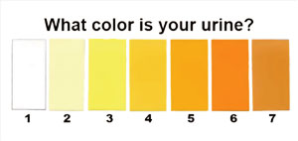Examine the urine carefully by eye! Comment on the colour of the urine. Try to use words like **yellow**, **amber**, **dark** and **pale**.

**Protein**

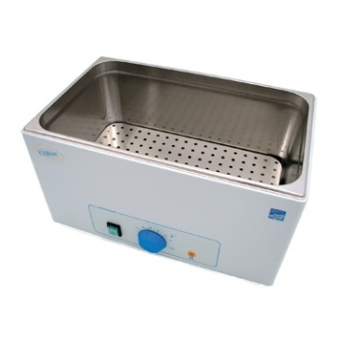Divide the sample equally between two test tubes. Put one tube into the hot water bath, and leave the other at room temperature. After a few minutes, take the test tube out of the water bath, and compare the heated and unheated urine. **If the heated sample is cloudier, it contains protein**. Note your result. Flush away the heated urine, and keep the unheated sample.

**pH**

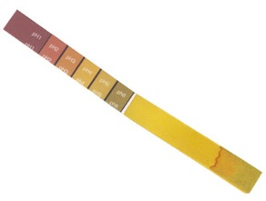Use the unheated sample to find out the pH of the unheated urine. Dip a piece **of universal indicator paper** into the urine. Quickly take it out, and leave it for 30 seconds. Compare the new colour with the pH colour chart, and note the pH number on in your results.

**Glucose**

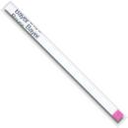Description: Picture of glucose chartThe last test is to find out if the urine contains glucose. Dip a **Clinistix** into the unheated urine sample, and **immediately** take it out. Count to ten, then check the colour with the colour chart. Record whether the urine is **negative**, **light**, **medium** or **dark** (dark means a lot of glucose).

[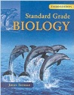](http://www.google.co.uk/url?sa=i&rct=j&q=&esrc=s&frm=1&source=images&cd=&cad=rja&uact=8&ved=0ahUKEwjApdCIh73JAhXH7RQKHdceA84QjRwIBw&url=http://www.amazon.co.uk/Standard-Grade-Biology-3rd-Edn/dp/0340789573&psig=AFQjCNF08aofxcZSOMfcddt6C2bP5u6NNA&ust=1449141528751522)**EXTENSION TASKS**

Your teacher may suggest that you use the Standard Grade Biology Text Book [Third Edition] to **extend** your knowledge in some of the following areas.

**NB** this content is not part of the Learning Outcomes and will not be in the test.

**Skeleton and Bones-** find out about the composition of bone on p145-146

**Joints -** find out about another type of joint and the structure of joints on 147-149

**Lungs** – find out more about the air sacs and how the lungs clean themselves on p154-157

**Heart** – find out more about blood flow, blood vessels and components of blood on p158162

**Water Balance** - find out how the body gains and loses water on p130-131

**Kidney Function & Failure** - find out how the kidney works and what happens when it doesn’t work on P132-136

**TIME TO DO SOME REVISION….**

* [](http://www.google.co.uk/url?q=http://findicons.com/icon/24960/highlighter_yellow_01&sa=U&ei=xOcwVaCqItjiasHygagE&ved=0CDwQ9QEwEg&usg=AFQjCNFpsXWVQOg-ovDcvsZA0dSkJYiktg)Update your glossary
* Highlight the key words in your Learning Outcome Checklist.

[](http://www.google.co.uk/url?sa=i&rct=j&q=&esrc=s&frm=1&source=images&cd=&cad=rja&uact=8&ved=0ahUKEwjApdCIh73JAhXH7RQKHdceA84QjRwIBw&url=http://www.amazon.co.uk/Standard-Grade-Biology-3rd-Edn/dp/0340789573&psig=AFQjCNF08aofxcZSOMfcddt6C2bP5u6NNA&ust=1449141528751522)

* Use the Standard Grade Biology Text Book

[Third Edition pages 145-163, 172, 130-137]

* [](http://www.google.co.uk/url?sa=i&rct=j&q=&esrc=s&frm=1&source=images&cd=&cad=rja&uact=8&ved=0ahUKEwjS-5S_h73JAhXDtxoKHaUTBdsQjRwIBw&url=http://www.gbt.literaryconnections.co.uk/&psig=AFQjCNHB-qzRVXnJMTfckFhYAQrHj4q3fw&ust=1449141653388786)Test Question Practice Booklet available. Complete as many of these as possible. Remember to **mark your answers** and follow up any errors with extra revision.

Also try the following activities - available from your teacher.

* Loop Frame Revison Game
* Osmoregulation Bingo
* Circulatory System Sequence Cards
* Blank Diagrams of Lungs, Heart and Urinary System

and

* Glossary Fashcards available at <http://www.hns.org.uk/bio/>