S3 Biology Peebles High School

booklet number

always take the booklet with your number on it

you are responsible for this booklet in class

Genetics

Pupil Booklet

[](http://www.mystshopper.com/blog) read information [http://t0.gstatic.com/images?q=tbn:ANd9GcTytTalOAoKypPWp3ziPjNrzU0x4SxsZZpxFg7SYsVUKyekU-XDp4__JQ:i0.wp.com/illustrationstock.net/wp-content/uploads/2015/04/thinking-clipart-yco6jdkcE.png%3Fresize%3D50%252C50](http://www.google.co.uk/url?q=http://illustrationstock.net/palm-tree/&sa=U&ei=2eIwVZmXE8vhaqiogPAF&ved=0CB4Q9QEwAw&usg=AFQjCNErBTtGpfJtj4q2T5H9rvC3wTMQdQ) think

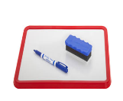 mini white board activity work sheet

[](http://www.google.co.uk/url?q=http://www.rhinostationery.com/pack-of-20-rhino-a4-exercise-book-80-page-light-green-f6m/&sa=U&ei=xd4wVYqvOcm2abH0gegL&ved=0CBYQ9QEwAA&usg=AFQjCNFzzM3djH9c-l0kMAFETBmfWvvPAg)work in your jotter group work

[](http://www.google.co.uk/url?q=http://findicons.com/icon/24960/highlighter_yellow_01&sa=U&ei=xOcwVaCqItjiasHygagE&ved=0CDwQ9QEwEg&usg=AFQjCNFpsXWVQOg-ovDcvsZA0dSkJYiktg)Highlight

Underlined Headings should be written into your jotter with the date

 ICT [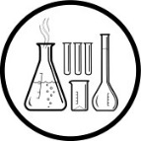](http://www.clipartpanda.com/clipart_images/vector-chemical-test-tubes-34003632)Practical work [](http://findicons.com/icon/158565/home?id=360421)Homework

**Variation**



Collect a **Variation Bingo Card** and

follow your teacher’s instructions to play the game.

[http://t0.gstatic.com/images?q=tbn:ANd9GcTytTalOAoKypPWp3ziPjNrzU0x4SxsZZpxFg7SYsVUKyekU-XDp4__JQ:i0.wp.com/illustrationstock.net/wp-content/uploads/2015/04/thinking-clipart-yco6jdkcE.png%3Fresize%3D50%252C50](http://www.google.co.uk/url?q=http://illustrationstock.net/palm-tree/&sa=U&ei=2eIwVZmXE8vhaqiogPAF&ved=0CB4Q9QEwAw&usg=AFQjCNErBTtGpfJtj4q2T5H9rvC3wTMQdQ)

What do you think Variation means?

What do all the pieces of information in the shaded boxes on the bingo card have in common?

Make a list of some other differences between people.

[](http://www.mystshopper.com/blog) The differences between individuals in a population are called **variation.**

Each way that individuals in a population vary is called a **characteristic.**

The particular version of a characteristic seen in an individual is described as their **phenotype**.



On a mini white board make a list of the possible **phenotypes** for the following **characteristics**.

1. Eye colour in humans.
2. Blood group in humans.
3. Coat colour in Labrador dogs.
4. Height of sunflowers
5. Hand span of humans

[http://t0.gstatic.com/images?q=tbn:ANd9GcTytTalOAoKypPWp3ziPjNrzU0x4SxsZZpxFg7SYsVUKyekU-XDp4__JQ:i0.wp.com/illustrationstock.net/wp-content/uploads/2015/04/thinking-clipart-yco6jdkcE.png%3Fresize%3D50%252C50](http://www.google.co.uk/url?q=http://illustrationstock.net/palm-tree/&sa=U&ei=2eIwVZmXE8vhaqiogPAF&ved=0CB4Q9QEwAw&usg=AFQjCNErBTtGpfJtj4q2T5H9rvC3wTMQdQ)

Why do you think it is more difficult to list the phenotypes of the 4th and 5th characteristics in the list above?

[](http://www.mystshopper.com/blog)Characteristics can show **discrete** variation or **continuous** variation.

Characteristics that fall into **separate categories** show discrete variation.

Characteristics that show a **wide range of values** are described as continuous variation.

[](http://www.google.co.uk/url?q=http://www.rhinostationery.com/pack-of-20-rhino-a4-exercise-book-80-page-light-green-f6m/&sa=U&ei=xd4wVYqvOcm2abH0gegL&ved=0CBYQ9QEwAA&usg=AFQjCNFzzM3djH9c-l0kMAFETBmfWvvPAg)In your jotter **make a table** to show several examples of each type of variation (as shown below). Underneath it write a **definition** of variation and a **description** of the two types of variation.

|  |  |
| --- | --- |
| discrete variation | continuous variation |
|  |  |

[](http://www.google.co.uk/url?q=http://www.rhinostationery.com/pack-of-20-rhino-a4-exercise-book-80-page-light-green-f6m/&sa=U&ei=xd4wVYqvOcm2abH0gegL&ved=0CBYQ9QEwAA&usg=AFQjCNFzzM3djH9c-l0kMAFETBmfWvvPAg)update your Glossary

**[http://t0.gstatic.com/images?q=tbn:ANd9GcTytTalOAoKypPWp3ziPjNrzU0x4SxsZZpxFg7SYsVUKyekU-XDp4__JQ:i0.wp.com/illustrationstock.net/wp-content/uploads/2015/04/thinking-clipart-yco6jdkcE.png%3Fresize%3D50%252C50](http://www.google.co.uk/url?q=http://illustrationstock.net/palm-tree/&sa=U&ei=2eIwVZmXE8vhaqiogPAF&ved=0CB4Q9QEwAw&usg=AFQjCNErBTtGpfJtj4q2T5H9rvC3wTMQdQ)DNA**

Look at the pictures below. What do they all have in common?

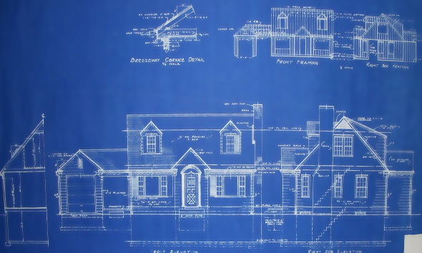1.

2.

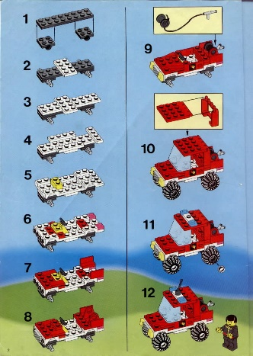3.

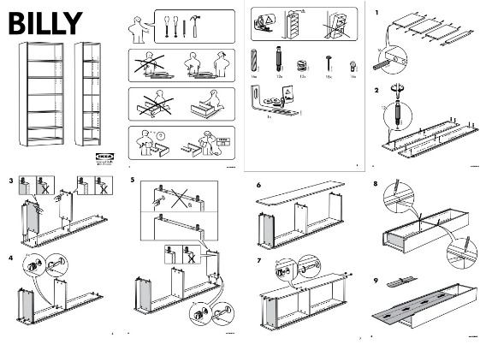 4.

5.

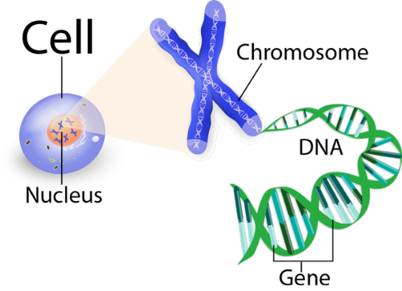

CLUES

1. Is a blue print and contains the instructions for building a ….

2. Is a recipe book and contains the instructions for making a…

3. Is from a Lego kit and contains the instructions for building a…

4. Is from flat-pack furniture box and contains the instructions for building a…

5. Is DNA from a chromosome in the nucleus of a cell and contains the instructions for making a…

Twig Glossary films

<https://www.twigonglow.com/film/glossary/nucleus-biology-828/>

<https://www.twigonglow.com/film/glossary/gene-326/>

[](http://www.mystshopper.com/blog)The genetic material of a cell is found in the **nucleus,** on thread like structures called **chromosomes.** Chromosomes are made of long strands of a chemical called **DNA.** A **gene** is a section of a chromosome. Genes contain the **instructions that control** **characteristics**. Each species has a **characteristic number** of chromosomes. Every cell in your body contains **two** copies of every **gene** required to make a human being. One of these copies is from your mother and the other from your father. They came together when your mother’s **egg** was fertilised by your father’s **sperm**. These genes work together to form your **inherited features**. Humans have **46** chromosomes (23 pairs) inside the nucleus of each cell.

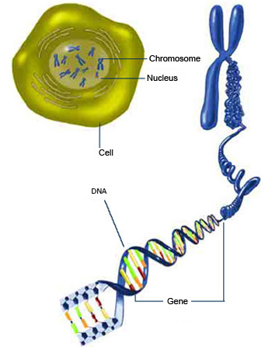

[](http://www.google.co.uk/url?q=http://www.rhinostationery.com/pack-of-20-rhino-a4-exercise-book-80-page-light-green-f6m/&sa=U&ei=xd4wVYqvOcm2abH0gegL&ved=0CBYQ9QEwAA&usg=AFQjCNFzzM3djH9c-l0kMAFETBmfWvvPAg) Collect the **Cell to gene diagram**, label it and stick it into your jotter.

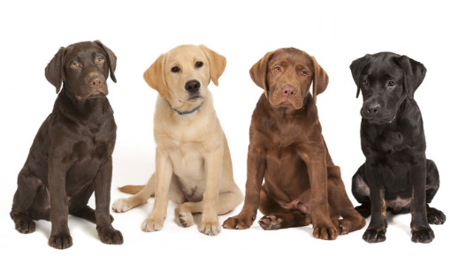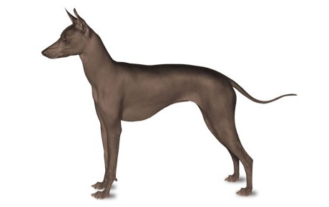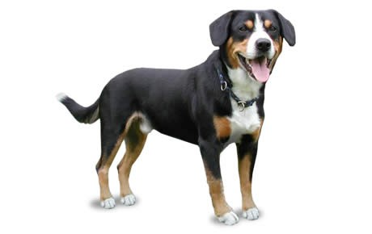

**Dog DNA**

A set of instructions called DNA makes a “recipe” for characteristics in all organisms. Information in a DNA strand is grouped into small segments (**genes**). Each segment is made of even smaller units (like recipes are made of words, and words are made of letters). Differences in the DNA “alphabet” are what make differences in characteristics (just like a different sequence of letters makes different words, and a different recipe)

Follow the directions below to create a DNA recipe for a dog. Using the Dog Characteristics Key, read your DNA recipe and make a drawing of your dog showing all of its characteristics

Instructions:

1. Collect an envelope containing “Dog DNA”, a Dog Characteristics Key and blank piece of A4 paper.

2. Pick a piece of dog DNA out of the envelope. This is the ‘**gene’** for body shape

3. Look at the symbols on the DNA strip you have chosen. Match the pattern to one you see on the Dog Characteristics Key for body shape.

4. On your blank paper draw the body shape that matches the strip you chose.

5. Repeat steps 2-4 for the next characteristic on the key.

6. Tape the second piece of DNA to the first to make one long strand. This will become the DNA recipe for your entire dog.

7. Repeat these steps for each of the characteristics listed on the Dog Characteristics Key.

8. When you have finished, you should have a drawing of your dog with all of its characteristics.

9. Compare the picture of your dog to the others in the class.

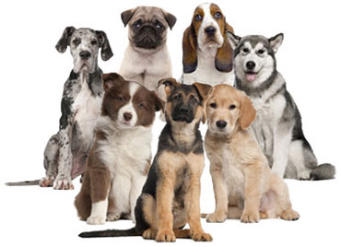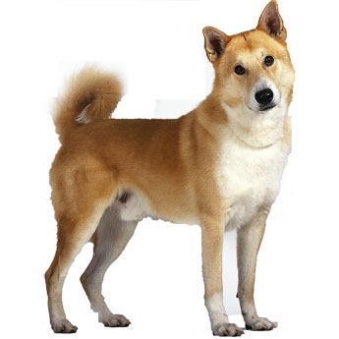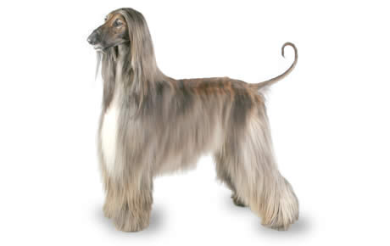

[](http://www.google.co.uk/url?q=http://www.rhinostationery.com/pack-of-20-rhino-a4-exercise-book-80-page-light-green-f6m/&sa=U&ei=xd4wVYqvOcm2abH0gegL&ved=0CBYQ9QEwAA&usg=AFQjCNFzzM3djH9c-l0kMAFETBmfWvvPAg)update your Glossary

**[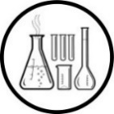](http://www.clipartpanda.com/clipart_images/vector-chemical-test-tubes-34003632)Gene Wizardry - Gel electrophoresis**

Because **genes** are sections of DNA it is possible to separate them and identify them. This can be done using a technique called gel electrophoresis. This is the technique forensic scientists would use in CSI to identify criminals from samples found at crime scenes.

You will attempt to profile the genes of some wizards using gel electrophoresis to determine which of them has an evil gene.

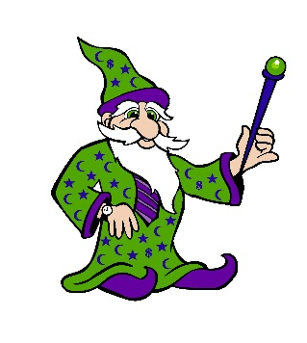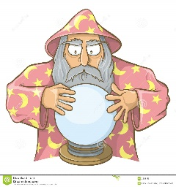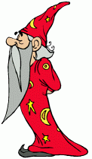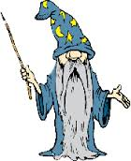Most wizards are good ones. However, a change in a wizard’s DNA can result in a lack of judgement and genes controlling good behaviour can change so that the behaviour of the wizard becomes evil. The evidence comes from preparing a genetic profile of the wizard using a sample of blood which, for wizards, happens to be green. A blood sample has been taken from each wizard, the DNA extracted and chopped into sections. When an electric current is applied to them, the genes will separate out to allow you to look at the powers belonging to each wizard. Try to identify the wizard with the evil gene, which will be red in colour.

GeeKnee SlimeMould BooBelle Diabolical

**Wizardry Powers**

|  |  |  |
| --- | --- | --- |
| **Gene Colour** | **Power** | **Example** |
| **Pink** | Teleportation | Take yourself to Disney World in the blink of an Eye! |
| **Yellow** | Transfiguration | Turn a Prince into a frog! |
| **Blue** | Vanish | What happens to Homework......! |
| **Red** | Evil | Don’t Ask!! |
| **Orange** | Creation | Whip up an Ice Cream Soda in a flash! |

**Method:**

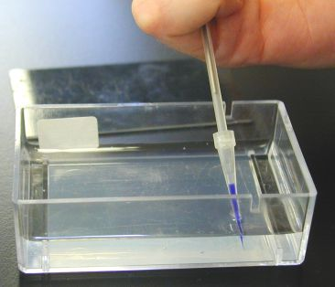

1. Using a micropipette, place **20 µl** of each blood sample into a separate well in the gel you have been given. Ensure that the tip of the pipette lies below the surface of the water but does not pierce the gel at the bottom of the well.  Should this happen, the ‘DNA’ will disappear under the gel.

Load the gels **in order** (see below) using the first letter of each wizard’s name:

**G S B D**

Place the gel on a piece of **black laminated paper**.

1. Insert the electrodes at each end of the tank and attach crocodile clips. The black (negative) clips goes at the end nearest the wells.
2. Connect the tank to the batteries with the red clip at the positive end.

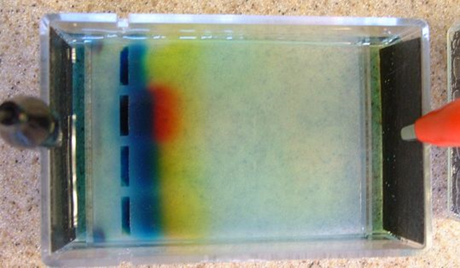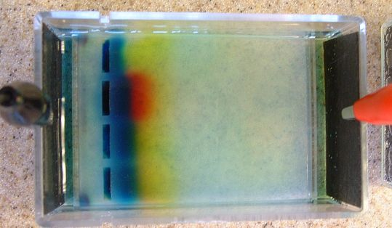

1. Leave for 30 minutes and remove the connections and take out the gels.

[](http://www.google.co.uk/url?q=http://www.rhinostationery.com/pack-of-20-rhino-a4-exercise-book-80-page-light-green-f6m/&sa=U&ei=xd4wVYqvOcm2abH0gegL&ved=0CBYQ9QEwAA&usg=AFQjCNFzzM3djH9c-l0kMAFETBmfWvvPAg) Record your results in a table in your jotter

|  |  |  |
| --- | --- | --- |
| name of wizard | colour(s) of genes | wizard powers |
|  |  |  |

**The Evil Wizard is____________________________**

**Inheritance**

[](http://www.mystshopper.com/blog)An individual’s characteristics are the product of their **genes** (and the environment). For each **gene** there can be more than one version of it. These versions or forms of the gene are called **alleles**. Not all alleles are expressed equally. Alleles which mask the effects of others are said to be **dominant**, while those which are masked are said to be **recessive**.  **Dominant** alleles are usually represented by a **capital** letter, while **recessive** genes are represented by a **lower case** letter.

[](http://www.google.co.uk/url?q=http://www.rhinostationery.com/pack-of-20-rhino-a4-exercise-book-80-page-light-green-f6m/&sa=U&ei=xd4wVYqvOcm2abH0gegL&ved=0CBYQ9QEwAA&usg=AFQjCNFzzM3djH9c-l0kMAFETBmfWvvPAg)**Copy** the table and see if you can **complete** it with the missing alleles.

|  |  |  |
| --- | --- | --- |
| **Gene** | **Dominant Allele** | **Recessive Allele** |
| Eye Colour  Tongue rolling  Pea flower colour  Pea plant height  Human ear lobes | Roller  Free | Blue  White  Dwarf |

[](http://www.mystshopper.com/blog)These facts can help us make predictions regarding the outcome of breeding experiments or **crosses**. Here is an example with **pea flower colour.** Remember that the capital letter represents the dominant allele and the lower case the recessive allele. Every individual pea plant cell has two genes for flower colour, one from each parent. The **gametes** carry one copy of each gene and fuse with a partner at **fertilisation**.

Parents Red flowering pea plant X White flowering pea plant

Alleles RR x rr

Sex Cells R r

Fertilisation Rr

**Since red (R) is the dominant allele, ALL the flowers of the offspring will be red in this cross.**

[](http://www.google.co.uk/url?q=http://www.rhinostationery.com/pack-of-20-rhino-a4-exercise-book-80-page-light-green-f6m/&sa=U&ei=xd4wVYqvOcm2abH0gegL&ved=0CBYQ9QEwAA&usg=AFQjCNFzzM3djH9c-l0kMAFETBmfWvvPAg)update your Glossary

Try the **Dragon Genetics Activity**

In this exercise each dragon has four genes, one on each chromosome, and there are two forms of each gene (two alleles).

|  |  |
| --- | --- |
| **Gene** | **Forms of the Gene (Alleles)** |
| Body colour | Red (R) or Purple (r) |
| Wings | Present (W) or absent(w) |
| Fire breathing | No (F) or Yes!(f) |
| Eye Colour | Green (G) or yellow(g) |

Not all genes have equal “strength”. If a gene is represented by a Capital letter, it will mask the other gene and only it will appear in the dragon’s features. We say this is the **dominant** gene. e.g. a dragon will inherit two genes for wings (one from each parent) and the outcome is shown here:

WW: dragon has wings

Ww: dragon has wings

ww: dragon has **no** wings

You will be given **four chromosomes (lollipop sticks) of different colours.** Your teacher will explain the game to you so that you can play it. You should **draw** the dragons that are produced from your dragon breeding on the **sheet** provided. Stick your finished sheet into your jotter.

youtube video Mendelian Genetics (8m34s) <http://www.youtube.com/watch?v=-mRphwIVEcM>

Your teacher will show you how to carry out other crosses using a **Punnet Square**.

[](http://www.google.co.uk/url?q=http://www.rhinostationery.com/pack-of-20-rhino-a4-exercise-book-80-page-light-green-f6m/&sa=U&ei=xd4wVYqvOcm2abH0gegL&ved=0CBYQ9QEwAA&usg=AFQjCNFzzM3djH9c-l0kMAFETBmfWvvPAg)There are lots of practice questions on the next two pages. Draw a **punnet square** for each one, and have your updated **glossary** handy!

**Monohybrid Inheritance Practice with Punnet Squares**

1. A TT (tall) plant is crossed with a tt (short plant). What percentage of the offspring will be tall?
2. A Tt plant is crossed with a Tt plant. What percentage of the offspring will be short?
3. A round seeded plant (Rr) is crossed with a round seeded plant (RR). What percentage of   
   the offspring will be (RR)?



1. A round seeded plant with two different alleles is crossed with a wrinkled seeded plant. What are the genotypes of the parents?   
   What percentage of the offspring will also have both alleles the same?
2. In pea plants purple flowers are dominant to white flowers.   
   If two white flowered plants are cross, what percentage of their offspring will be white flowered?
3. A white flowered plant is crossed with a plant that has one of each allele. What percentage of the offspring will have purple flowers?
4. Two plants, both with one of each type of allele for the gene that controls flower colour are crossed. What percentage of their offspring will have purple flowers?   
   What percentage will have white flowers?
5. In guinea pigs, the allele for short hair is dominant.   
   What genotypes would a short haired guinea pig have?   
   What genotype would a long haired guinea pig have?
6. Show the cross for a short haired guinea pig that has both alleles the same and a long haired guinea pig. What percentage of the offspring will have short hair?
7. Show the cross for two guinea pigs that both have two different alleles.  
   What percentage of the offspring will have short hair?   
   What percentage of the offspring will have long hair?

**Example Crosses using Punnet Squares**

1. A man with **free ear lobes (F)** and a woman with **attached ear lobes (f)** decide to start a family. Use the letters **F**/**f** to represent the alleles for ear lobe type. **Copy** and **complete** the table:

|  |  |  |
| --- | --- | --- |
| **individual** | **phenotype** | **genotype(s)** |
| male |  | **or** |
| female |  |  |

1. What alleles (genotype) must the man have if **all** of his children have free ear lobes?
2. What alleles (genotype) must the man have if **some** of his children have attached ear lobes?
3. Assuming they have a large family and some of his children have attached ear lobes, what **is the predicted phenotype ratio** of his children?

2. A tall pea plant is crossed with a dwarf pea plant. The new plants are tall and dwarf. Use the letters **T**/**t** for the alleles.

1. What are the **genotypes** of each parent plant?
2. State the **genotypes** of the offspring plants.
3. Whatis the **predicted ratio** of tall to dwarf plants in the offspring?
4. 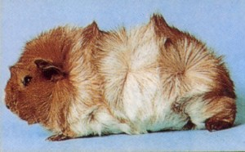[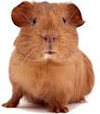](http://search.orange.co.uk/mediaredirect?sv=pictures&src=google_image&q=guinea+pigs&b=-9&brand=ouk&uu=00000132e8801f692391d6280c13ebcf&d=www.2ndchance.info&thumb=http://images-partners.google.com/images?q=tbn:ANd9GcQUs-tj1XiRFy336oYSpwTkcz9xwvbIkjrROTNI8mAH69zKW80BKh3dew:http://www.2ndchance.info/guineapigcareA.jpg&pictitle=%20Guinea%20Pig%20%20Care&picname=%20Guinea%20Pig%20%20Care&picweight=19kb&fullsize=http://www.2ndchance.info/guineapigcareA.jpg&pagefrom=http://www.2ndchance.info/guineapigcare.htm&height=386&width=338&geom=338x386%20-%20%20guinea%20pig%20%20care&pge=1&pos=3&)300 pea plants are produced. What is the **predicted number** of tall and dwarf plants in the offspring?

3. In guinea pigs the allele for smooth coat (**S**) is dominant to the allele for rosette coat(**s**). Guinea pigs with rosette coats can be sold for twice the price of those with smooth coats.

Smooth Rosette

A breeder has only males and females with the **phenotype** smooth coats, yet one pair have produced some babies with rosette coats.

1. State **genotypes** of the parents.
2. What is the **predicted phenotype** **ratio** (ie smooth to rosette coat) in their offspring?
3. Before they died, this pair managed to produce 316 babies. **How many** of their offspring were predicted to be smooth and **how many** were predicted to be rosette?

In reality, 241 guinea pigs were born with smooth coats and 75 with rosette coats.

[](http://www.google.co.uk/url?q=http://www.rhinostationery.com/pack-of-20-rhino-a4-exercise-book-80-page-light-green-f6m/&sa=U&ei=xd4wVYqvOcm2abH0gegL&ved=0CBYQ9QEwAA&usg=AFQjCNFzzM3djH9c-l0kMAFETBmfWvvPAg)**Copy**:

Predicted ratios of offspring may vary from actual ratios because **fertilisation is a random event.** It is not possible to guarantee which sex cells will actually join together at the moment of fertilisation.

[](http://www.google.co.uk/url?q=http://www.rhinostationery.com/pack-of-20-rhino-a4-exercise-book-80-page-light-green-f6m/&sa=U&ei=xd4wVYqvOcm2abH0gegL&ved=0CBYQ9QEwAA&usg=AFQjCNFzzM3djH9c-l0kMAFETBmfWvvPAg)update your Glossary

**Sex Determination**

[](http://www.mystshopper.com/blog)The gender of a baby is determined by the type of sex chromosomes that the child inherits from each parent. Among all the chromosomes a human has, two are required to determine the sex of the baby. These are called the sex chromosomes. There are two type of sex chromosomes, X and Y.

At the moment of fertilisation, if a child inherits two X chromosomes (X from the egg cell and X from the sperm cell), then the child will be female. If the child inherits an X and a Y chromosome (X from the egg cell and Y from the sperm cell) then the child will be male.

Your teacher may show you how to work out the **sex of offspring** using punnet squares.

[http://t0.gstatic.com/images?q=tbn:ANd9GcTytTalOAoKypPWp3ziPjNrzU0x4SxsZZpxFg7SYsVUKyekU-XDp4__JQ:i0.wp.com/illustrationstock.net/wp-content/uploads/2015/04/thinking-clipart-yco6jdkcE.png%3Fresize%3D50%252C50](http://www.google.co.uk/url?q=http://illustrationstock.net/palm-tree/&sa=U&ei=2eIwVZmXE8vhaqiogPAF&ved=0CB4Q9QEwAw&usg=AFQjCNErBTtGpfJtj4q2T5H9rvC3wTMQdQ)At fertilisation what is the chance of a boy or girl being made?

Why do some families have only sons or only daughters?

[](http://www.google.co.uk/url?q=http://www.rhinostationery.com/pack-of-20-rhino-a4-exercise-book-80-page-light-green-f6m/&sa=U&ei=xd4wVYqvOcm2abH0gegL&ved=0CBYQ9QEwAA&usg=AFQjCNFzzM3djH9c-l0kMAFETBmfWvvPAg)update your Glossary

**Karyotype**

[](http://www.mystshopper.com/blog)Karyotypes are the arrangement of chromosomes that an individual possesses. Chromosomes are usually arranged with their partner chromosome (the one which carries the same genes). They are usually recognised because they are the same size and shape.

Staining the chromosomes results in similar banding patterns as in the picture:

These **bands** represent the position of **genes** on the chromosome.

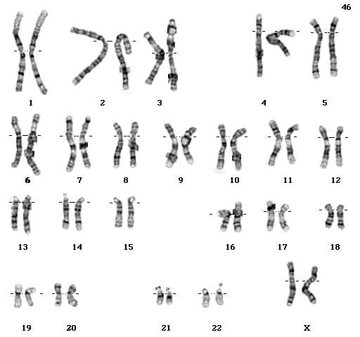[](http://www.google.co.uk/url?q=http://www.rhinostationery.com/pack-of-20-rhino-a4-exercise-book-80-page-light-green-f6m/&sa=U&ei=xd4wVYqvOcm2abH0gegL&ved=0CBYQ9QEwAA&usg=AFQjCNFzzM3djH9c-l0kMAFETBmfWvvPAg) Collect the karyotype diagrams and stick into your jotter.

* Label each karyotype diagram with the correct gender.
* What is the other difference apart from gender, between the two karyotypes? Once you have spotted it try to find out what is the result of this difference.

**Answer** these questions in full sentences.

* How many chromosomes are found in the nucleus of a human cell?
* How many chromosomes are inherited from each parent at fertilisation?
* The last pair of chromosomes in a karyotype determine the sex of a child. State the chromosomes inherited by a girl and the chromosomes inherited by a boy.
* What do the bands on the stained chromosomes represent?

You may have the chance to do an interactive activity to make a karyotype

<http://learn.genetics.utah.edu/content/basics/karyotype/> [](http://www.google.co.uk/url?q=http://www.rhinostationery.com/pack-of-20-rhino-a4-exercise-book-80-page-light-green-f6m/&sa=U&ei=xd4wVYqvOcm2abH0gegL&ved=0CBYQ9QEwAA&usg=AFQjCNFzzM3djH9c-l0kMAFETBmfWvvPAg)update your Glossary

Research

There are some controversial biological procedures that have arisen from our greater understanding of genetics. Your teacher will outline a research task where you will have the opportunity to find out more about one of these areas. It is important that you chose your sources carefully and are able to justify why you chose them.

You may look into

* Gene therapy
* Pharming
* Transgenic animals
* Transgenic plants

**TIME TO DO SOME REVISION….**

* [](http://www.google.co.uk/url?q=http://findicons.com/icon/24960/highlighter_yellow_01&sa=U&ei=xOcwVaCqItjiasHygagE&ved=0CDwQ9QEwEg&usg=AFQjCNFpsXWVQOg-ovDcvsZA0dSkJYiktg)Update your glossary
* Highlight the key words in your Learning Outcome Checklist.

[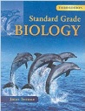](http://www.google.co.uk/url?sa=i&rct=j&q=&esrc=s&frm=1&source=images&cd=&cad=rja&uact=8&ved=0ahUKEwjApdCIh73JAhXH7RQKHdceA84QjRwIBw&url=http://www.amazon.co.uk/Standard-Grade-Biology-3rd-Edn/dp/0340789573&psig=AFQjCNF08aofxcZSOMfcddt6C2bP5u6NNA&ust=1449141528751522)

* Use the Standard Grade Biology Text Book

[Third Edition pages 180-183, 184-196, 199]

* [](http://www.google.co.uk/url?sa=i&rct=j&q=&esrc=s&frm=1&source=images&cd=&cad=rja&uact=8&ved=0ahUKEwjS-5S_h73JAhXDtxoKHaUTBdsQjRwIBw&url=http://www.gbt.literaryconnections.co.uk/&psig=AFQjCNHB-qzRVXnJMTfckFhYAQrHj4q3fw&ust=1449141653388786)Test Question Practice Booklet available. Complete as many of these as possible. Remember to **mark your answers** and follow up any errors with extra revision.

Also try the following activities - available from your teacher.

* Genetics Dominoes
* Glossary Flashcards available at <http://www.hns.org.uk/bio/>