S2 Biology Peebles High School

booklet number

always take the booklet with your number on it

you are responsible for this booklet in class

Plants

Pupil Booklet

[](http://www.mystshopper.com/blog) read information [http://t0.gstatic.com/images?q=tbn:ANd9GcTytTalOAoKypPWp3ziPjNrzU0x4SxsZZpxFg7SYsVUKyekU-XDp4__JQ:i0.wp.com/illustrationstock.net/wp-content/uploads/2015/04/thinking-clipart-yco6jdkcE.png%3Fresize%3D50%252C50](http://www.google.co.uk/url?q=http://illustrationstock.net/palm-tree/&sa=U&ei=2eIwVZmXE8vhaqiogPAF&ved=0CB4Q9QEwAw&usg=AFQjCNErBTtGpfJtj4q2T5H9rvC3wTMQdQ) think

 mini white board activity work sheet

[](http://www.google.co.uk/url?q=http://www.rhinostationery.com/pack-of-20-rhino-a4-exercise-book-80-page-light-green-f6m/&sa=U&ei=xd4wVYqvOcm2abH0gegL&ved=0CBYQ9QEwAA&usg=AFQjCNFzzM3djH9c-l0kMAFETBmfWvvPAg)work in your jotter group work

[](http://www.google.co.uk/url?q=http://findicons.com/icon/24960/highlighter_yellow_01&sa=U&ei=xOcwVaCqItjiasHygagE&ved=0CDwQ9QEwEg&usg=AFQjCNFpsXWVQOg-ovDcvsZA0dSkJYiktg)Highlight

Underlined Headings should be written into your jotter with the date

 ICT [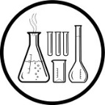](http://www.clipartpanda.com/clipart_images/vector-chemical-test-tubes-34003632)Practical work [](http://findicons.com/icon/158565/home?id=360421)Homework

[http://t0.gstatic.com/images?q=tbn:ANd9GcTytTalOAoKypPWp3ziPjNrzU0x4SxsZZpxFg7SYsVUKyekU-XDp4__JQ:i0.wp.com/illustrationstock.net/wp-content/uploads/2015/04/thinking-clipart-yco6jdkcE.png%3Fresize%3D50%252C50](http://www.google.co.uk/url?q=http://illustrationstock.net/palm-tree/&sa=U&ei=2eIwVZmXE8vhaqiogPAF&ved=0CB4Q9QEwAw&usg=AFQjCNErBTtGpfJtj4q2T5H9rvC3wTMQdQ)Revision Quiz

***What can you remember from***

***S1 Science and S2 Biology Units?***

 

1. On a **mini white board** draw a typical plant cell like the one below.

[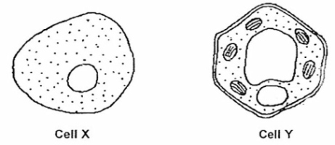](http://www.google.co.uk/url?sa=i&rct=j&q=&esrc=s&source=images&cd=&cad=rja&uact=8&ved=0CAcQjRw&url=http://www.oldschool.com.sg/index.php/module/PublicAccess/action/Wrapper/sid/ea5f3768e0dae62aa6d01beee8123931/cmbn_id/1133/qba/1&ei=nD-IVc67LoeaygOwxpWoAQ&bvm=bv.96339352,d.bGQ&psig=AFQjCNFegFZo6afutqsPOnVDKyhXzvwdNg&ust=1435078917711590)

Plant cell

Try to label the **six** parts of the plant cell – CLUE - three parts are the same in animal cells. [S1 Cells to Systems]

1. Which part of the plant cell is green? [S1 Cells to Systems]
2. What is at the beginning of every food chain? [S2 Ecosystems]
3. Why do food chains start like this? [S2 Ecosystems]
4. What do the arrows in a food chain show? [S2 Ecosystems]
5. What are the two raw materials of aerobic respiration? [S2 Cells]
6. Why do all living cells need to respire? [S2 Cells]
7. If there is a higher concentration of a substance in one area what process causes it to move to an area where the concentration is lower? [S2 Cells]
8. Which part of a cell controls the entry and exit of substances from a cell? [S2 Cells]
9. What forms of energy come from the sun? [S1 Energy]
10. What is the form of energy stored in food? [S1 Energy]
11. What is the name for reproduction involving only one parent? [S2 Species Survival]

Photosynthesis

[](http://www.mystshopper.com/blog)Cells from the green parts of plants contain structures called **chloroplasts**. The chloroplasts contain a green pigment called **chlorophyll**. This pigment can trap the energy in **light** and use it to convert **carbon dioxide** and **water** into **oxygen** and **glucose**. Plants therefore change **light** energy into **chemical** energy which is stored in the molecules of glucose. This process is called **photosynthesis**. The glucose can then be stored as **starch**.

[](http://www.google.co.uk/url?q=http://www.rhinostationery.com/pack-of-20-rhino-a4-exercise-book-80-page-light-green-f6m/&sa=U&ei=xd4wVYqvOcm2abH0gegL&ved=0CBYQ9QEwAA&usg=AFQjCNFzzM3djH9c-l0kMAFETBmfWvvPAg)Use the information in the above paragraph to complete the Photosynthesis Equation (as shown below) and **copy into your jotter.**

_________ (energy)

________ + ________ ________ + ________

(raw materials) ­____________ (products)

(green pigment)

stored as

 A short clip explaining photosynthesis <http://www.bbc.co.uk/education/clips/zbm2tfr>

________

Photosynthesis Experiments

Each of the two following experiments uses a **product of photosynthesis** as evidence that the process is taking place. The first experiment involves testing leaves for the storage carbohydrate, **starch**. The second experiment involves measuring the production of **oxygen** in aquatic (water dwelling) plants.

[](http://www.clipartpanda.com/clipart_images/vector-chemical-test-tubes-34003632)Experiment 1

Aim to find out if plants need light, CO2 and chlorophyll for photosynthesis.

Method

Use plants that have had one of the requirements removed.

Test the plants’ leaves for the presence of starch using the method on the next page.

1. Boil the leaf in a beaker of water, to burst the cells open.

2. SWITCH THE BUNSEN BURNER OFF

NB Methylated spirt is VERY FLAMMABLE and must be

kept AWAY FROM FLAMES

3. Place the leaf in a boiling tube with methylated spirits, place the boiling tube into the beaker of hot water from step 1, boil the leaf in methylated spirits to dissolve the green pigment, this gives a white back ground for the starch test.

4. Rinse the leaf in the beaker of warm water to soften it.

Methylated spirits

5. Spread the leaf out on a dimple tile and cover with iodine, to test for starch.

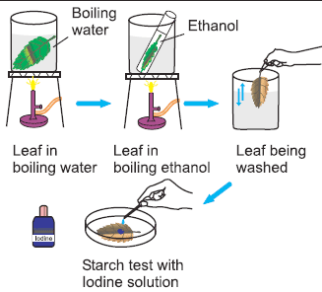

You will use this method for each of the leaves you test.

[](http://www.google.co.uk/url?q=http://www.rhinostationery.com/pack-of-20-rhino-a4-exercise-book-80-page-light-green-f6m/&sa=U&ei=xd4wVYqvOcm2abH0gegL&ved=0CBYQ9QEwAA&usg=AFQjCNFzzM3djH9c-l0kMAFETBmfWvvPAg)Record the Method by **copying** and **completing** the following table

|  |  |
| --- | --- |
| step | reason |
| boil the leaf |  |
|  | dissolve green pigment |
| rinse leaf in water |  |
| add iodine |  |

|  |  |
| --- | --- |
| condition of leaf | starch present (yes / no) |
| green with CO2 and light |  |
| white with CO2 and light |  |
| green with light, NO CO2 |  |
| green with CO2 , NO light |  |

[](http://www.google.co.uk/url?q=http://www.rhinostationery.com/pack-of-20-rhino-a4-exercise-book-80-page-light-green-f6m/&sa=U&ei=xd4wVYqvOcm2abH0gegL&ved=0CBYQ9QEwAA&usg=AFQjCNFzzM3djH9c-l0kMAFETBmfWvvPAg)Results ***copy*** *and* ***complete*** *the table*

[](http://www.google.co.uk/url?q=http://www.rhinostationery.com/pack-of-20-rhino-a4-exercise-book-80-page-light-green-f6m/&sa=U&ei=xd4wVYqvOcm2abH0gegL&ved=0CBYQ9QEwAA&usg=AFQjCNFzzM3djH9c-l0kMAFETBmfWvvPAg)Conclusion  *Look back at the Aim.* ***Write a conclusion*** *in your jotter.*

 Recap [www.twigonglow.com/experiment/photosynthesis-and-starch-4171/](http://www.twigonglow.com/experiment/photosynthesis-and-starch-4171/)

[](http://www.clipartpanda.com/clipart_images/vector-chemical-test-tubes-34003632)Experiment 2 Elodea Bubbler Investigation

Aim to find out the effect of changing light intensity on the rate of photosynthesis.

Method

Look at the diagram below.

Your teacher may show you a demonstration similar to it.

[](http://www.google.co.uk/url?q=http://www.rhinostationery.com/pack-of-20-rhino-a4-exercise-book-80-page-light-green-f6m/&sa=U&ei=xd4wVYqvOcm2abH0gegL&ved=0CBYQ9QEwAA&usg=AFQjCNFzzM3djH9c-l0kMAFETBmfWvvPAg)**Collect** a copy of the diagram, **stick** it into your jotter and **label** it.



Elodea (pond weed)

[http://t0.gstatic.com/images?q=tbn:ANd9GcTytTalOAoKypPWp3ziPjNrzU0x4SxsZZpxFg7SYsVUKyekU-XDp4__JQ:i0.wp.com/illustrationstock.net/wp-content/uploads/2015/04/thinking-clipart-yco6jdkcE.png%3Fresize%3D50%252C50](http://www.google.co.uk/url?q=http://illustrationstock.net/palm-tree/&sa=U&ei=2eIwVZmXE8vhaqiogPAF&ved=0CB4Q9QEwAw&usg=AFQjCNErBTtGpfJtj4q2T5H9rvC3wTMQdQ)1. How could you use this equipment to carry out an investigation into the effect of **light intensity** on the rate of photosynthesis?

2. Why do you need the heat shield there?

3. How could you prove the bubbles of gas were oxygen? [you might need to ask a chemist!]

4. How does the CO2 get into the plant cells? [CLUE - you learned about this in the Cells unit]

4. How would you ensure your investigation was a fair test?

5. How would you make your results reliable?

6. What changes would you make if you were investigating the effect of temperature on the rate of photosynthesis?

7. What changes would you make if you were investigating the effect of carbon dioxide on the rate of photosynthesis?



It takes a long time to set up and collect results from the real Elodea bubbler. A quicker way to do this experiment is virtually……

<http://www.kscience.co.uk/animations/photolab.htm>

|  |  |
| --- | --- |
| input variables | values |
| light intensity | 10,20,30,40,50 |
| temperature (oC) | 10, 25, 40 |
| CO2 concentration | high, low |
| light colour  ONLY DO THIS IF TOLD TO DO THE EXTENSION TASK | green, blue,  white, orange |

|  |  |
| --- | --- |
| output variable | number of bubbles per minute |

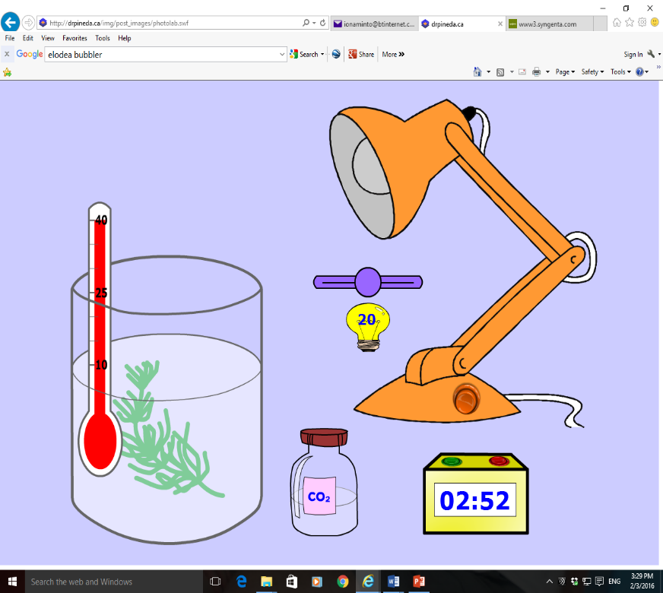Virtual experiment

Use the website (on previous page) to collect results for **one** of the first three input variables in the table. Others in your group should do the remaining input variables. Keep the light colour white.

[](http://www.google.co.uk/url?q=http://www.rhinostationery.com/pack-of-20-rhino-a4-exercise-book-80-page-light-green-f6m/&sa=U&ei=xd4wVYqvOcm2abH0gegL&ved=0CBYQ9QEwAA&usg=AFQjCNFzzM3djH9c-l0kMAFETBmfWvvPAg)**Record** your Results in a suitable **table** & share them with others in your group who have done a different input variable.

[](http://www.google.co.uk/url?q=http://www.rhinostationery.com/pack-of-20-rhino-a4-exercise-book-80-page-light-green-f6m/&sa=U&ei=xd4wVYqvOcm2abH0gegL&ved=0CBYQ9QEwAA&usg=AFQjCNFzzM3djH9c-l0kMAFETBmfWvvPAg) *[****copy*** *and* ***complete*** *the following]*

Conclusions

As the **light intensity** increased the rate of photosynthesis ___________.

As the **temperature** increased the rate of photosynthesis ___________.

As the **carbon dioxide concentration** increased the rate of photosynthesis ___________.

EXTENSION TASK

With the light intensity, temperature and CO2 concentration at the highest levels, find out **the effect of changing the colour of the light on the rate of photosynthesis.**

Make a note of what you find out.

Can you explain the results? HINT – find out about the colours in white light & why do green objects, like leaves, look green.

HELP SHEET AVAILABLE FROM YOUR TEACHER

Plant Processes

In the Cells unit you learned that all living cells need to carry out respiration.

This is the process that **releases** the energy from glucose. The energy is then used for cellular activities e.g. cell division for growth and repair.

glucose + oxygen -> carbon dioxide + water

You also now know that plants **use** light energy to make glucose by the process of photosynthesis.

carbon dioxide + water -> glucose + oxygen

[http://t0.gstatic.com/images?q=tbn:ANd9GcTytTalOAoKypPWp3ziPjNrzU0x4SxsZZpxFg7SYsVUKyekU-XDp4__JQ:i0.wp.com/illustrationstock.net/wp-content/uploads/2015/04/thinking-clipart-yco6jdkcE.png%3Fresize%3D50%252C50](http://www.google.co.uk/url?q=http://illustrationstock.net/palm-tree/&sa=U&ei=2eIwVZmXE8vhaqiogPAF&ved=0CB4Q9QEwAw&usg=AFQjCNErBTtGpfJtj4q2T5H9rvC3wTMQdQ) SPOT THE DIFFERENCE [http://t0.gstatic.com/images?q=tbn:ANd9GcTytTalOAoKypPWp3ziPjNrzU0x4SxsZZpxFg7SYsVUKyekU-XDp4__JQ:i0.wp.com/illustrationstock.net/wp-content/uploads/2015/04/thinking-clipart-yco6jdkcE.png%3Fresize%3D50%252C50](http://www.google.co.uk/url?q=http://illustrationstock.net/palm-tree/&sa=U&ei=2eIwVZmXE8vhaqiogPAF&ved=0CB4Q9QEwAw&usg=AFQjCNErBTtGpfJtj4q2T5H9rvC3wTMQdQ)

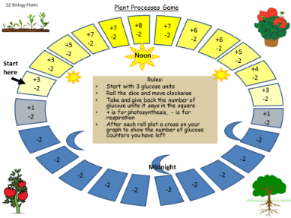

Play the Plant Processes Game

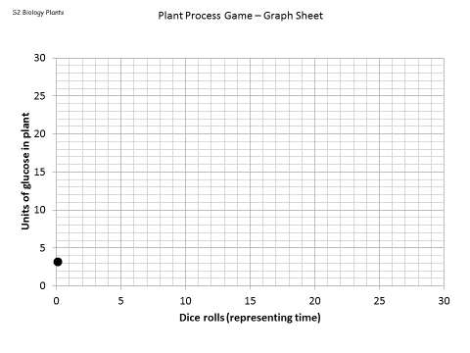[](http://www.google.com/url?sa=i&rct=j&q=&esrc=s&source=images&cd=&cad=rja&uact=8&ved=0ahUKEwiPxJKsguTKAhXELg8KHXl3DMQQjRwIBw&url=http://www.clipartbest.com/dice-pictures&psig=AFQjCNG5ke2ySak1sUxBUsiwa-_e2yv01Q&ust=1454878308187318)Collect

* a game board
* one die
* one leaf
* [](http://www.google.com/url?sa=i&rct=j&q=&esrc=s&source=images&cd=&cad=rja&uact=8&ved=0ahUKEwiA46KXg-TKAhWBHg8KHbo1CVMQjRwIBw&url=http://www.penandpaper.co.in/p/3872/stabilo-whiteboard-marker&bvm=bv.113370389,d.ZWU&psig=AFQjCNFYymLzdVFhYl6TD7k3XC1vlLwVGA&ust=1454878542276867)white board pen
* laminated graph sheet

[](http://www.google.co.uk/url?q=http://www.rhinostationery.com/pack-of-20-rhino-a4-exercise-book-80-page-light-green-f6m/&sa=U&ei=xd4wVYqvOcm2abH0gegL&ved=0CBYQ9QEwAA&usg=AFQjCNFzzM3djH9c-l0kMAFETBmfWvvPAg) Answer these Questions in your jotter.

1. Draw a rough sketch of the pattern in your graph then below it write a description of the pattern you see in it.
2. Each part of the game represents something that really happens in plants.
   1. Which cell process produces glucose?
   2. Why did you only sometimes add glucose units?
   3. Which cell process used up glucose?
   4. Why did you lose glucose units every turn?
   5. What real factors might affect the amount of photosynthesis in a day?
3. Explain why you got the pattern you did.
4. Why does a plant carry out respiration?

Your teacher may use the Plant Processes True / false activity to test your understanding.

[](http://www.google.co.uk/url?q=http://www.rhinostationery.com/pack-of-20-rhino-a4-exercise-book-80-page-light-green-f6m/&sa=U&ei=xd4wVYqvOcm2abH0gegL&ved=0CBYQ9QEwAA&usg=AFQjCNFzzM3djH9c-l0kMAFETBmfWvvPAg) Update your Glossary

[](http://www.google.com/url?sa=i&rct=j&q=&esrc=s&source=images&cd=&cad=rja&uact=8&ved=0ahUKEwjw4ZiJj-TKAhXBgA8KHWHCCEAQjRwIBw&url=http://www.clipartpanda.com/categories/open-book-outline-clipart&psig=AFQjCNH_BDawsTTxi9zLatmMUzoRNKxRmw&ust=1454881755414660)Photosynthesis – Rate Limiting Factors

[http://t0.gstatic.com/images?q=tbn:ANd9GcTytTalOAoKypPWp3ziPjNrzU0x4SxsZZpxFg7SYsVUKyekU-XDp4__JQ:i0.wp.com/illustrationstock.net/wp-content/uploads/2015/04/thinking-clipart-yco6jdkcE.png%3Fresize%3D50%252C50](http://www.google.co.uk/url?q=http://illustrationstock.net/palm-tree/&sa=U&ei=2eIwVZmXE8vhaqiogPAF&ved=0CB4Q9QEwAw&usg=AFQjCNErBTtGpfJtj4q2T5H9rvC3wTMQdQ)Look at the recipe for one loaf of bread and the weekly delivery to a small bakery.

* 15g fresh yeast
* 300ml milk
* 500g strong white flour
* 5g salt
* 25g butter

Bread Recipe

(makes one loaf)

[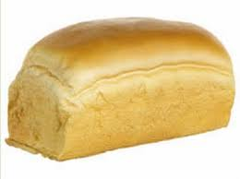](https://www.google.com/imgres?imgurl=http://static.comicvine.com/uploads/original/12/126443/3927113-1737733905-bread-.jpeg&imgrefurl=http://forums.elderscrollsonline.com/en/discussion/124789/want-my-full-loaf-of-bread-please-not-actually-about-bread-xd&h=298&w=400&tbnid=4h6DCxGr0PuhRM:&docid=S4wSmZtzaM-rqM&ei=JGu2VuL9JIHTPLLgoaAD&tbm=isch&ved=0ahUKEwjin_3ij-TKAhWBKQ8KHTJwCDQQMwiMAShTMFM)

To: Forsooths Bakery

From : IngredientsRUs

500g Yeast

9litres Milk

13 kg Flour(strong white)

200g Salt

750g butter

***Now answer the following questions***

How many loaves of bread can the bakery make in one week?

What ingredient is limiting the production of bread?

One week the delivery company sent 1kg of butter by mistake. Could they make more loaves?

How could they change their order to increase their production to 30 loaves?

[](http://www.google.co.uk/url?q=http://www.rhinostationery.com/pack-of-20-rhino-a4-exercise-book-80-page-light-green-f6m/&sa=U&ei=xd4wVYqvOcm2abH0gegL&ved=0CBYQ9QEwAA&usg=AFQjCNFzzM3djH9c-l0kMAFETBmfWvvPAg)**Copy**

A limiting factor is a factor that holds up a process because it is in short supply.

Three factors can limit the rate of photosynthesis, they are

* Light intensity.
* Carbon dioxide concentration.
* Temperature.

**[](http://www.google.co.uk/url?q=http://www.rhinostationery.com/pack-of-20-rhino-a4-exercise-book-80-page-light-green-f6m/&sa=U&ei=xd4wVYqvOcm2abH0gegL&ved=0CBYQ9QEwAA&usg=AFQjCNFzzM3djH9c-l0kMAFETBmfWvvPAg)Answer** the following questions in your jotter

|  |  |  |  |
| --- | --- | --- | --- |
| **Plant** | **Units of CO2 available to plant** | **Units of water available to plant** | **Units of light available to plant** |
| A | 12 | 12 | 12 |
| B | 6 | 12 | 24 |
| C | 12 | 24 | 12 |
| D | 12 | 12 | 24 |
| E | 24 | 12 | 12 |

1. Assume that to produce 1 unit of sugar by photosynthesis, each of the plants referred to in the following table must receive 3 units of CO2, 3 units of water and 6 units of light.
2. How much sugar will plant A be able to make?
3. Which factor is in shortest supply and is holding up plant A’s photosynthesis?
4. Which plant will be able to make the greatest number of sugar units?
5. If plant E is given an unlimited supply of light energy, how many units of sugar will it be able to make under the conditions given?



1. The diagram opposite shows an investigation into the effect of light intensity on photosynthetic rate, similar to the virtual experiment you did.

Use the results in the table below to -

|  |  |  |
| --- | --- | --- |
| Distance from plant (cm) | Units of light intensity | bubbles per minute |
| 100 | 4 | 4 |
| 60 | 11 | 10 |
| 40 | 25 | 19 |
| 30 | 45 | 24 |
| 25 | 64 | 25 |
| 20 | 100 | 25 |

a) Plot a graph of number of bubbles per minute (y axis) against light intensity (x axis)

b) At low light intensity, what effect does increasing light intensity have on the rate of photosynthesis?

c) At high light intensity, what effect does increasing light intensity have on the rate of photosynthesis? Suggest a reason for this.

d) What is the **percentage increase** in bubbles per minute when the light intensity increases from 4 to 100 units?

CLUE % change = change / original x 100

Watch the short clip on BBc bitesize

<http://www.bbc.co.uk/education/clips/z3y7tfr>

**[](http://www.google.co.uk/url?q=http://www.rhinostationery.com/pack-of-20-rhino-a4-exercise-book-80-page-light-green-f6m/&sa=U&ei=xd4wVYqvOcm2abH0gegL&ved=0CBYQ9QEwAA&usg=AFQjCNFzzM3djH9c-l0kMAFETBmfWvvPAg)Draw a sketch of the graphs** for the effect of increasing CO2 concentration and Temperature on the rate of photosynthesis.

For each one **write a description** and **explanation** of the shape of the line.

[](http://findicons.com/icon/158565/home?id=360421)You can now do Homework Exercise 1

Leaf Structure & Photosynthesis

Structures for gas exchange

[http://t0.gstatic.com/images?q=tbn:ANd9GcTytTalOAoKypPWp3ziPjNrzU0x4SxsZZpxFg7SYsVUKyekU-XDp4__JQ:i0.wp.com/illustrationstock.net/wp-content/uploads/2015/04/thinking-clipart-yco6jdkcE.png%3Fresize%3D50%252C50](http://www.google.co.uk/url?q=http://illustrationstock.net/palm-tree/&sa=U&ei=2eIwVZmXE8vhaqiogPAF&ved=0CB4Q9QEwAw&usg=AFQjCNErBTtGpfJtj4q2T5H9rvC3wTMQdQ)Name the two gases that a plant exchanges with the atmosphere.

Which gas goes in and which one comes out of the leaf?

How do you think the leaf gets these gases in/out?

[](http://www.clipartpanda.com/clipart_images/vector-chemical-test-tubes-34003632)Look a bit closer at an imprint of the underside of a leaf.

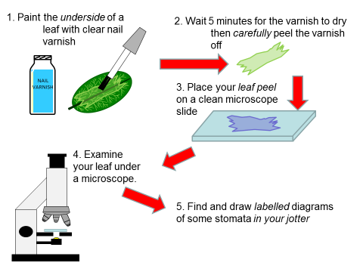

Leaf Structure

[](http://www.mystshopper.com/blog)What you saw under the microscope were stomata, special structures that allow gas exchange for photosynthesis. As in all areas of Biology, structure and function are closely related. The function of leaves is to photosynthesise. You will now find out about other structures in leaves that allow them to carry out their function.

**Raw materials** (carbon dioxide and water) must be **delivered** to the leaf

**Essential requirements** (light and chlorophyll) must be **available**.

**Products** (glucose and oxygen) must be **taken away** from the leaf.

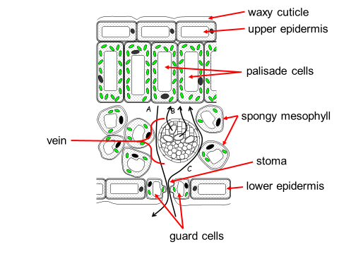[](http://www.google.co.uk/url?q=http://www.rhinostationery.com/pack-of-20-rhino-a4-exercise-book-80-page-light-green-f6m/&sa=U&ei=xd4wVYqvOcm2abH0gegL&ved=0CBYQ9QEwAA&usg=AFQjCNFzzM3djH9c-l0kMAFETBmfWvvPAg)Collect a diagram of a cross section through a leaf and stick it into you jotter.

Add the **correct labels** including a description of what the **three arrows, A, B & C represent.**

Make a **part and function** table.

|  |  |
| --- | --- |
| part of the leaf | function of this part |
|  |  |

*Resources to help you include the twig film below and SG Biology Text book.*

**[www.twigonglow.com/film/parts-of-the-plant-leaves-1181/](http://www.twigonglow.com/film/parts-of-the-plant-leaves-1181/)

Your teacher may **test** you with the

Leaf Structure – What’s Missing? powerpoint

[](http://www.google.co.uk/url?q=http://www.rhinostationery.com/pack-of-20-rhino-a4-exercise-book-80-page-light-green-f6m/&sa=U&ei=xd4wVYqvOcm2abH0gegL&ved=0CBYQ9QEwAA&usg=AFQjCNFzzM3djH9c-l0kMAFETBmfWvvPAg)

Update your Glossary

Collect a Photosynthesis MIND MAP worksheet. Put as much detail as you can to make a revision resource for the Plants TEST.

[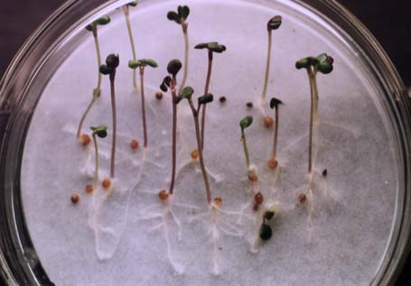](http://www.google.com/url?sa=i&rct=j&q=&esrc=s&source=images&cd=&cad=rja&uact=8&ved=0ahUKEwii2vDLxMXLAhUDkw8KHd5UAn4QjRwIBw&url=http://www2.lv.psu.edu/jxm57/irp/germinat.html&psig=AFQjCNG3bMkM3mAaCjrOy0o9r8WibmKpnw&ust=1458228985420299)Seed Germination

[](http://www.mystshopper.com/blog)Seeds are the product of **sexual reproduction** in plants.

Germination in plants is the process by which a dormant seed begins to sprout and grow into a seedling when they have **WATER, OXYGEN** and **WARMTH** (W.O.W.).

You will investigate one variable to find out how it affects seed germination.

[](http://www.clipartpanda.com/clipart_images/vector-chemical-test-tubes-34003632)

Seed Germination investigation

You should **plan**, **carry out** and **write up a report** on this.

Suggested input variables- volume of water, temperature, pH of water, type of seed.

Investigation planning

OUTPUT VARIABLE

What am I going to measure as my results?

How will I record this data?

INPUT VARIABLE

What am I going to change ?

AIM

What am I trying to find out?

RELIABLE RESULTS

How will I make my results more reliable?

FAIR TEST / CONTROLLED VARIABLES

Which variables must I keep the same so that they do not affect the results?

EQUIPMENT

What will I need in order to carry out this experiment?

Collect an Investigation planning help sheet if you need assistance with writing the report.

[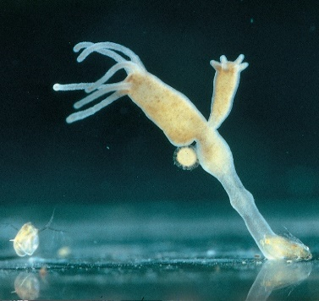](http://www.google.com/url?sa=i&rct=j&q=&esrc=s&source=images&cd=&cad=rja&uact=8&ved=0ahUKEwiX6tCmpYfLAhWBxRQKHbDeAEQQjRwIBw&url=http://www.carolina.com/freshwater-coelenterates/budding-hydra-living/132804.pr&bvm=bv.114733917,d.d24&psig=AFQjCNGc7Y_35LYKqQCfTiFKmXr_fE1vMQ&ust=1456090266576588)Asexual Reproduction in Plants

[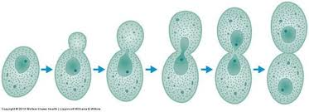](https://www.google.com/imgres?imgurl=https://classconnection.s3.amazonaws.com/580/flashcards/2884580/jpg/yeast_reproducing_by_budding1363975669358.jpg&imgrefurl=https://www.studyblue.com/notes/note/n/mycoplasm-picture-iding/deck/6032669&h=236&w=650&tbnid=F88ku5rDtKQcEM:&docid=MbQwZQPgdJ93rM&ei=7oDMVp-dGMT3OcKTnogE&tbm=isch&ved=0ahUKEwifzNbSn47LAhXEew4KHcKJB0EQMwiIAShLMEs)[http://t0.gstatic.com/images?q=tbn:ANd9GcTytTalOAoKypPWp3ziPjNrzU0x4SxsZZpxFg7SYsVUKyekU-XDp4__JQ:i0.wp.com/illustrationstock.net/wp-content/uploads/2015/04/thinking-clipart-yco6jdkcE.png%3Fresize%3D50%252C50](http://www.google.co.uk/url?q=http://illustrationstock.net/palm-tree/&sa=U&ei=2eIwVZmXE8vhaqiogPAF&ved=0CB4Q9QEwAw&usg=AFQjCNErBTtGpfJtj4q2T5H9rvC3wTMQdQ)Remember these?

On a **mini whiteboard** write down the main features of **asexual reproduction.**

Use the Standard Grade Biology Text Book [Third Edition pages 93-94] to find out about **Runners** and **Tubers**.

Your teacher may show you some examples.

[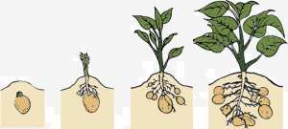](https://greenmylife-wpengine.netdna-ssl.com/wp-content/uploads/2014/11/Lifecycle-of-a-Potato.gif)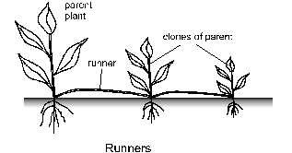[](http://www.google.co.uk/url?q=http://www.rhinostationery.com/pack-of-20-rhino-a4-exercise-book-80-page-light-green-f6m/&sa=U&ei=xd4wVYqvOcm2abH0gegL&ved=0CBYQ9QEwAA&usg=AFQjCNFzzM3djH9c-l0kMAFETBmfWvvPAg)In your jotter **make notes** about these types of asexual reproduction in plants. **Collect** the diagrams, **label** them and include them in your **notes**

[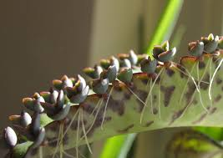](https://www.google.com/imgres?imgurl=https://upload.wikimedia.org/wikipedia/commons/3/36/Bryophyllum_daigremontianum_nahaufnahme1.jpg&imgrefurl=https://commons.wikimedia.org/wiki/File:Bryophyllum_daigremontianum_nahaufnahme1.jpg&h=1171&w=1659&tbnid=MkEOUTqw3n3Z3M:&docid=IV_tEYVBXAkUBM&ei=uYHMVvuxA4L4OZeEovgN&tbm=isch&ved=0ahUKEwi78qezoI7LAhUCfA4KHReCCN8QMwhZKBwwHA)Look at the photographs below. They show another method of asexual reproduction in a plant called Bryophyllum or Mexican Hat plant. Your teacher may show you a real one.

[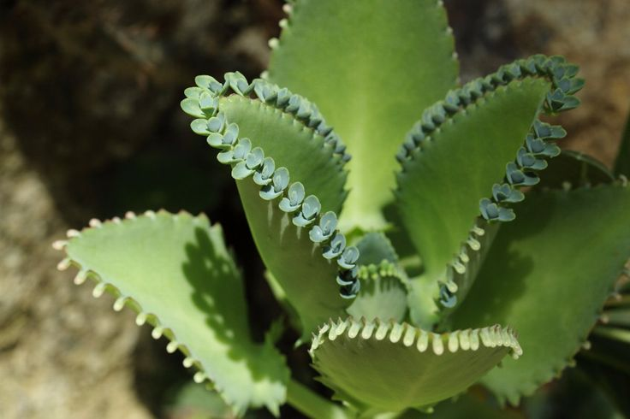](https://www.google.com/url?sa=i&rct=j&q=&esrc=s&source=images&cd=&cad=rja&uact=8&ved=0ahUKEwj639HFkYfLAhWBuhQKHVxfDmMQjRwIBw&url=https://www.pinterest.com/pin/397020523376553861/&psig=AFQjCNGnbdHxRg7kEj5HJVTlIbHOk7EC9Q&ust=1456084956910589)

[](https://www.google.com/imgres?imgurl=http://sunriseterracecc.com/wp-content/uploads/2015/05/sombrero.jpg&imgrefurl=http://sunriseterracecc.com/join-us-for-national-nursing-home-week/&h=280&w=550&tbnid=6--PTGMMxx3BsM:&docid=l_EQxET6nqBcbM&ei=ZYXMVrTDOsT0O7GrvMAM&tbm=isch&ved=0ahUKEwj0ifzzo47LAhVE-g4KHbEVD8gQMwiOAShUMFQ)

[http://t0.gstatic.com/images?q=tbn:ANd9GcTytTalOAoKypPWp3ziPjNrzU0x4SxsZZpxFg7SYsVUKyekU-XDp4__JQ:i0.wp.com/illustrationstock.net/wp-content/uploads/2015/04/thinking-clipart-yco6jdkcE.png%3Fresize%3D50%252C50](http://www.google.co.uk/url?q=http://illustrationstock.net/palm-tree/&sa=U&ei=2eIwVZmXE8vhaqiogPAF&ved=0CB4Q9QEwAw&usg=AFQjCNErBTtGpfJtj4q2T5H9rvC3wTMQdQ)With a partner **discuss** how you think the Bryophyllum reproduces asexually **and** how it gets its common name.

Check your ideas with your teacher.

[](http://www.clipartpanda.com/clipart_images/vector-chemical-test-tubes-34003632) Your teacher may show you how to grow a plant from a cutting

Commercial Uses of Plants

[](http://www.mystshopper.com/blog) The vast **variety** of plants with their huge range of **properties** provides us with many **uses** of plants. Industry has exploited these uses to make plants very important economically.



[http://t0.gstatic.com/images?q=tbn:ANd9GcTytTalOAoKypPWp3ziPjNrzU0x4SxsZZpxFg7SYsVUKyekU-XDp4__JQ:i0.wp.com/illustrationstock.net/wp-content/uploads/2015/04/thinking-clipart-yco6jdkcE.png%3Fresize%3D50%252C50](http://www.google.co.uk/url?q=http://illustrationstock.net/palm-tree/&sa=U&ei=2eIwVZmXE8vhaqiogPAF&ved=0CB4Q9QEwAw&usg=AFQjCNErBTtGpfJtj4q2T5H9rvC3wTMQdQ)In **small groups brainstorm** your ideas on the commercial uses of plants. For each **use** try to name a **specific plant** e.g. FOOD - potato

[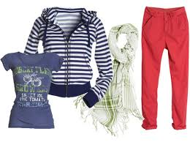](https://www.google.com/imgres?imgurl=http://assets.inhabitat.com/files/hmorganic_springwomens1.jpg&imgrefurl=http://inhabitat.com/sustainable-style-hm-spring-09-organic-collection/&h=400&w=537&tbnid=IxJD9UpnS9BgUM:&docid=GzrvriMzEvnEXM&ei=4cXVVszON8b7UKSxnrgE&tbm=isch&ved=0ahUKEwiMw8nV9p_LAhXGPRQKHaSYB0cQMwiAAShGMEY)The following pictures may help you.

[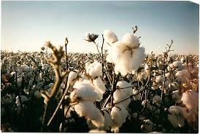](https://www.google.com/imgres?imgurl=http://www.earth-wear.com/scan_cotton_bowl.bmp&imgrefurl=http://www.earth-wear.com/&h=600&w=893&tbnid=RqmrJ2fYEBGbRM:&docid=TtSEkCNPjxlnEM&ei=K8bVVt-rKYiFUfOJmIAP&tbm=isch&ved=0ahUKEwif7d_49p_LAhWIQhQKHfMEBvA4ZBAzCBQoETAR)

[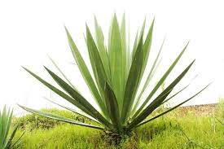](https://www.google.com/imgres?imgurl=http://azizilife.com/images/productImages/Sisal_Plant-_web.jpg&imgrefurl=http://azizilife.com/products/sisal-peace-basket&h=333&w=500&tbnid=58Qz-xBXrG9pBM:&docid=DyIv73bJEOtH7M&ei=kMbVVq60AsmbU_PbqKgN&tbm=isch&ved=0ahUKEwiuvM2o95_LAhXJzRQKHfMtCtUQMwhaKCAwIA)

[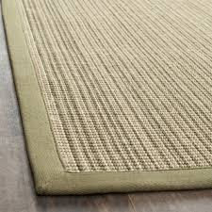](https://www.google.com/imgres?imgurl=http://ak1.ostkcdn.com/images/products/6430762/6430762/Dream-Natural-Fiber-Green-Sisal-Rug-3-x-5-P14034859.jpeg&imgrefurl=http://www.overstock.com/Home-Garden/3x5-4x6-Rugs/Sisal,/material,/1191/subcat.html&h=320&w=320&tbnid=UOMc0cK_raIiLM:&docid=Mmt0_kdCf7h_bM&ei=kMbVVq60AsmbU_PbqKgN&tbm=isch&ved=0ahUKEwiuvM2o95_LAhXJzRQKHfMtCtUQMwhfKCUwJQ)

[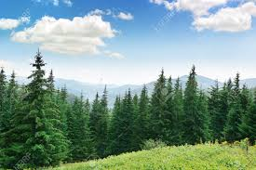](https://www.google.com/imgres?imgurl=http://previews.123rf.com/images/Serg_v/Serg_v1509/Serg_v150900055/45244918-Beautiful-pine-trees-on-background-high-mountains-Stock-Photo-forest-tree-pine.jpg&imgrefurl=http://www.123rf.com/stock-photo/pine_trees.html&h=867&w=1300&tbnid=IErz2Au_CVLQfM:&docid=NLnE7TbVBLrDOM&ei=XMfVVty8DsGqUrDxt1A&tbm=isch&ved=0ahUKEwjc2vyJ-J_LAhVBlRQKHbD4DQoQMwh8KEIwQg)[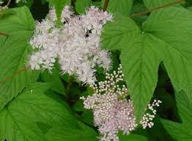](https://www.google.com/imgres?imgurl=http://medicinalherbinfo.org/images/Meadowsweet1.jpg&imgrefurl=http://medicinalherbinfo.org/herbs/Meadowsweet.html&h=257&w=350&tbnid=IaEVurHzTjnK0M:&docid=K2myn-bozCKyPM&ei=VMjVVsiiCYWRUY-KqLAK&tbm=isch&ved=0ahUKEwjInJiA-Z_LAhWFSBQKHQ8FCqYQMwg-KBkwGQ)

[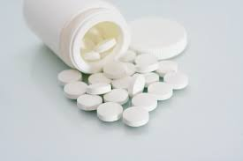](https://www.google.com/imgres?imgurl=http://guardianlv.com/wp-content/uploads/2013/11/freeimage-2982789.jpg&imgrefurl=http://guardianlv.com/2013/12/disease-like-cancer-and-dementia-cured-by-aspirin/&h=2304&w=3456&tbnid=LT7l9_TIRHN5cM:&docid=rT01KLU2V-J7wM&ei=gMjVVsGZA4feU4Olh3A&tbm=isch&ved=0ahUKEwjB2Y-V-Z_LAhUH7xQKHYPSAQ4QMwhQKBYwFg)[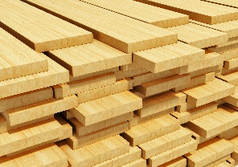](http://nuoxoda.com/)

[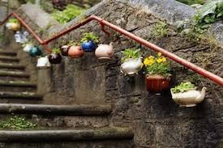](https://www.google.com/imgres?imgurl=http://thenaturalweddingcompany.co.uk/blog/wp-content/uploads/2012/02/living_wedding_centerpieces10.jpg&imgrefurl=http://www.greenbrideguide.com/content/creative-uses-living-plants&h=348&w=522&tbnid=vMsZ9r9FkeiKkM:&docid=ZL4fXNP2tIMdlM&ei=ZNnIVu30Osi9UZmrs4gE&tbm=isch&ved=0ahUKEwjttrO5o4fLAhXIXhQKHZnVDEE4yAEQMwgxKC4wLg)[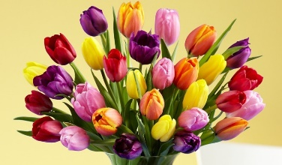](http://www.google.com/url?sa=i&rct=j&q=&esrc=s&source=images&cd=&cad=rja&uact=8&ved=0ahUKEwi8ovCQ-p_LAhXBORQKHQ7XAB8QjRwIBw&url=http://www.proflowers.com/blog/how-do-tulips-disperse-their-seeds&psig=AFQjCNEbHO8_N1RIaPF-7GLWrKcTW8lT1g&ust=1456937713440877)

Help sheets are available if you need more ideas.

Share your ideas with the class and then summarise the information in a table.

|  |  |
| --- | --- |
| commercial use of plants | plant example(s) |
|  |  |

**TIME TO DO SOME REVISION….**

* [](http://www.google.co.uk/url?q=http://findicons.com/icon/24960/highlighter_yellow_01&sa=U&ei=xOcwVaCqItjiasHygagE&ved=0CDwQ9QEwEg&usg=AFQjCNFpsXWVQOg-ovDcvsZA0dSkJYiktg)Update you glossary
* Highlight the key words in your Learning Outcome Checklist.

[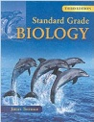](http://www.google.co.uk/url?sa=i&rct=j&q=&esrc=s&frm=1&source=images&cd=&cad=rja&uact=8&ved=0ahUKEwjApdCIh73JAhXH7RQKHdceA84QjRwIBw&url=http://www.amazon.co.uk/Standard-Grade-Biology-3rd-Edn/dp/0340789573&psig=AFQjCNF08aofxcZSOMfcddt6C2bP5u6NNA&ust=1449141528751522)

* Use the Standard Grade Biology Text Book

[Third Edition pages 101-108]

* [](http://www.google.co.uk/url?sa=i&rct=j&q=&esrc=s&frm=1&source=images&cd=&cad=rja&uact=8&ved=0ahUKEwjS-5S_h73JAhXDtxoKHaUTBdsQjRwIBw&url=http://www.gbt.literaryconnections.co.uk/&psig=AFQjCNHB-qzRVXnJMTfckFhYAQrHj4q3fw&ust=1449141653388786)Test Question Practice Booklet available. Remember to mark your answers and follow up any errors with extra revision.
* Photosynthesis MINDMAP
* Leaf Structure – What’s Missing? PowerPoint
* Use a variety of **study techniques** to revise for the test e.g.
  + Flashcards – look on http://www.hns.org.uk/bio/
  + Get someone at home to test you on the learning outcomes.