S2 Biology Ecosystems Food Chain and Food web HOMEWORK 1
DO NOT write on these sheets Number ______
1. The following food chains are from an ecosystem
Plant plankton -> shrimp -> herring
Plant plankton -> animal plankton -> herring
Plant plankton -> animal plankton -> sand eel -> cod
Plant plankton -> animal plankton -> mackerel -> cod
a) Draw a food web from the food chains
b) What two terms can be used for the shrimp and animal plankton?
c) What two terms can be used for the herring, sand eels and mackerel?
d) Suggest where this ecosystem would be found?

2. The diagram shows part of a food web in a heather moorland

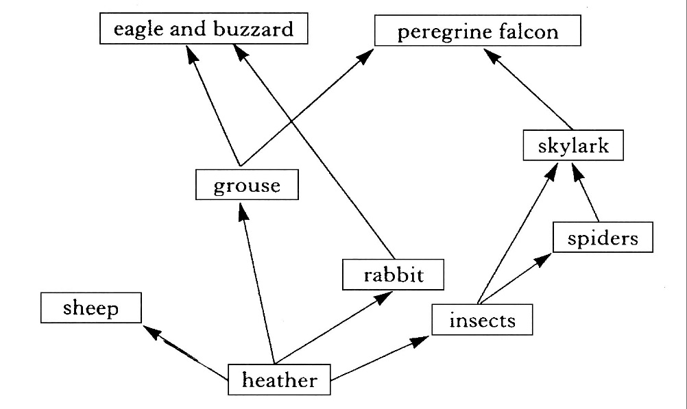

a) From the food web above give one food chain that contains 4 organisms.
b) Name the producer in this food web
c) Where do producers get their energy from?
d) What do the arrows show?
e) If all the grouse were killed.
i) Predict the effect on the population of heather GIVE YOUR REASONS
ii) Predict the effect on the population of rabbits . GIVE YOUR REASONS

