S2 Bio Genetics Homework 2 Inheritance DO NOT write on these sheets

Number ______

Look at the diagram below

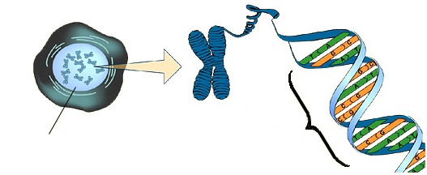

**1. Match the number for each part to the letter for its description**

A. The molecule that codes for the instructions to make a living organism

1. Nucleus

2. Chromosome

B. A structure composed of DNA and found in the nucleus of a cell

3. DNA

C. A section of DNA that carries the genetic code

4. Genes

D. A part of a cell that contains genetic information

**2. Copy and complete the following paragraph [missing words are in the bow below to help you].**

Humans have ­­­___ pairs of chromosomes in every cell. They exist in pairs because you get ____ of them from your mother and half from your _______. Egg cells and _______ cells are called gametes. Each gamete contains half of the parents 46 chromosomes, one of each pair. A ____ is a section of DNA which codes for a specific characteristic e.g. hair ______.

colour father 23 sperm gene half

3. Gel electrophoresis is a technique that can be used in DNA profiling.



a) Which suspect is most likely to have committed the crime?

b) Give a reason for your answer

DNA from blood at the scene of a crime

DNA from Suspect C

DNA from Suspect B

DNA from Suspect A

4. The diagram below show two chromosomes from a child.

Genes for eye colour, tongue-rolling ability and type of ear lobes are found on the chromosomes. The forms of each gene are represented by letters. The capital letter represents the dominant form of the gene.

a) What colour of eyes will the child have?

b) Will they be able to roll their tongue?

c) What type of ear lobes will they have?

d) Why does the child have two copies of this chromosome?

e) What is the name for the different forms of a gene?

f) What can you say about all the forms of the genes that are represented by lower case letters?

5. *Distichiasis* is a dominant characteristic in humans which causes the person to have two rows of eyelashes. A woman who is homozygous for the condition and a man who is unaffected have children.

What percentage of their children would be expected to have *Distichiasis?* [*Draw the punnet square to chow the cross.]*