S3 Biology Peebles High School

booklet number

always take the booklet with your number on it

you are responsible for this booklet in class

Biotechnology

Pupil Booklet

[](http://www.mystshopper.com/blog) read information [http://t0.gstatic.com/images?q=tbn:ANd9GcTytTalOAoKypPWp3ziPjNrzU0x4SxsZZpxFg7SYsVUKyekU-XDp4__JQ:i0.wp.com/illustrationstock.net/wp-content/uploads/2015/04/thinking-clipart-yco6jdkcE.png%3Fresize%3D50%252C50](http://www.google.co.uk/url?q=http://illustrationstock.net/palm-tree/&sa=U&ei=2eIwVZmXE8vhaqiogPAF&ved=0CB4Q9QEwAw&usg=AFQjCNErBTtGpfJtj4q2T5H9rvC3wTMQdQ) think

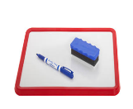 mini white board activity work sheet

[](http://www.google.co.uk/url?q=http://www.rhinostationery.com/pack-of-20-rhino-a4-exercise-book-80-page-light-green-f6m/&sa=U&ei=xd4wVYqvOcm2abH0gegL&ved=0CBYQ9QEwAA&usg=AFQjCNFzzM3djH9c-l0kMAFETBmfWvvPAg)work in your jotter group work

[](http://www.google.co.uk/url?q=http://findicons.com/icon/24960/highlighter_yellow_01&sa=U&ei=xOcwVaCqItjiasHygagE&ved=0CDwQ9QEwEg&usg=AFQjCNFpsXWVQOg-ovDcvsZA0dSkJYiktg)Highlight

Underlined Headings should be written into your jotter with the date

 ICT [](http://www.clipartpanda.com/clipart_images/vector-chemical-test-tubes-34003632)Practical work [](http://findicons.com/icon/158565/home?id=360421)Homework

**Biotechnology** is the use of biological processes, organisms, or systems to manufacture products intended to improve the quality of human life.

Enzymes are very useful biological molecules. What can you remember about them from S2?

In small groups write down all the facts about enzymes that you can remember from S2 Cells unit. If you need some help, see if you can find 10 words related to enzymes in the word search below (your teacher may give you your own copy of this)

L O C K A N D K E Y S L E D B

S I L X R S W B E P N S R E E

I U W N G R J Q E H A V L N U

S Z B A J H L C I L R A S A E

J M S S F E I P Y I C P N T T

Y E A B T F S R Q O Q I Y U U

R Q B L I R O A B T E E Z R B

F Q F C V H A Y L T W P M E T

I V P H P I M T O A Y O Q D M

D J L S Y P Z R E U T R L R U

F B O S W X P M A H W A D T M

J H F S O O V N H C I X C T I

P T S Y L A T A C Z B T F B T

A M Y L A S E S G S S R D A P

F D W M A G H L U H K P W N O

CHECK your answers with your teacher

EXTENSION - If you find the 10 words, can you write their meaning?

word search words = AMYLASE – CATALASE – CATALYST – DENATURED – LOCKANDKEY – OPTIMUM – PHOSPHORYLASE - PROTEIN – SPECIFIC - SUBSTRATE

**Enzymes in Industry** The action of enzymes has been applied in a variety of industries. You will learn about **three** of these.

**[](http://www.mystshopper.com/blog)Immobilising enzymes**

## Introduction

Lactase is an enzyme which breaks lactose to glucose and galactose:

**Lactase**

Lactose -----------------------------> Glucose + Galactose

Lactose, glucose and galactose are all **sugars**. Glucose and galactose taste sweeter and are easier to digest than lactose. Despite their traditional fondness for milk, cats are unable to digest large amounts of lactose. Milk can be treated with the enzyme to make a lactose-reduced milk suitable for cats or for humans who are lactose intolerant.

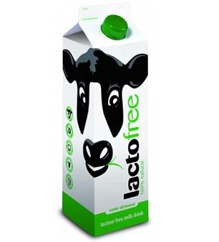 Although the production of a special ‘cat milk’ may seem trivial, an estimated 75% of the world’s human population are lactose intolerant in adulthood – it is **lactose tolerance** that is unusual.

Commercially, milk is treated by injecting an enzyme into the carton as UHT milk is packaged, or by using an **immobilised** enzyme – an enzyme that has been trapped on an inert material so that it can be used repeatedly.

In this activity, you will immobilise the lactase in calcium alginate beads held within a small column, over which the milk is passed.

[](http://www.clipartpanda.com/clipart_images/vector-chemical-test-tubes-34003632)

* **Method**

**READ THROUGH THE METHOD CAREFULLY**

1. Mix **2ml of** **lactase** **enzyme** with **8ml of** **sodium alginate solution**, then draw it up into a **10ml syringe.**
2. Add the alginate-enzyme mixture a drop at a time from the syringe to the calcium chloride solution and observe the formation of **small beads**. Do not allow the tip of the syringe to come into contact with the calcium chloride solution, as this will cause the alginate to harden, blocking the outlet. The beads, which contain the enzyme immobilised in a matrix of calcium alginate, should be allowed to harden for a few minutes.
3. **Separate the beads** of immobilised enzyme from the liquid with the tea strainer.
4. Carefully tip the **beads** into the clamped syringe barrel.
5. **Close the tubing** on the syringe barrel using a tubing clip.
6. **Test the milk before** treatment using the glucose test strips, to ensure that it does not contain any glucose.
7. Pour a small volume of **milk** over the enzyme beads, then undo the clip and allow the treated milk to run into a small beaker. (You may need to repeat this step a few times*)
8. **Test the milk leaving the column** using the glucose test strips. *If necessary, return the treated milk to the column until the desired concentration of glucose is achieved.

**Collect the Immobilisation Sequence cards.**

**Match the picture and description cards then put them in the correct order.**

[](http://www.clipartpanda.com/clipart_images/vector-chemical-test-tubes-34003632)**When your teacher has checked your cards, you are ready to carry out the experiment (A list of equipment and materials is on the next page)**

## Equipment and materials

### Equipment

* specially adapted syringe clamped in a Retort stand
* 10ml syringe
* 2 small beakers (100 ml)
* Tea strainer
* Glass stirring rod

### Materials

* 2 ml lactase enzyme
* 8 ml sodium alginate solution
* 100 ml calcium chloride solution
* 50 ml milk (not UHT milk)
* glucose test strips

Update your glossary [](http://www.google.co.uk/url?q=http://www.rhinostationery.com/pack-of-20-rhino-a4-exercise-book-80-page-light-green-f6m/&sa=U&ei=xd4wVYqvOcm2abH0gegL&ved=0CBYQ9QEwAA&usg=AFQjCNFzzM3djH9c-l0kMAFETBmfWvvPAg)

**Enzymes & fruit juice extraction**

[](http://www.mystshopper.com/blog)Fruit juice companies use a variety of different treatments and enzymes to enhance **fruit juice yield** (get more juice from the fruit)**.** The enzymes used are designed to break down the **cell wall** within the fruits and release the liquids and the sugars. **Pectinases, amylases and cellulases** all have different substrates so break down different parts of the cell wall of the fruit cells. During breakdown of the fruit cells a variety of polysaccharides are found within the juice extract making the juice hazy, **cloudy and thick** which reduces its appeal to customers and affect its market value. Pectinases can break down these insoluble compounds releasing soluble sugars which clarify the juice producing a **clearer, sweeter liquid**.

[](http://www.google.co.uk/url?q=http://www.rhinostationery.com/pack-of-20-rhino-a4-exercise-book-80-page-light-green-f6m/&sa=U&ei=xd4wVYqvOcm2abH0gegL&ved=0CBYQ9QEwAA&usg=AFQjCNFzzM3djH9c-l0kMAFETBmfWvvPAg)Use the information in the paragraph above to answer the following questions. write answers in full sentences in your jotter.

1. Which structure in the plant cells do the enzymes breakdown?
2. Name three enzymes used to increase the yield of juice extracted.
3. What feature of enzymes means that you need three different enzymes for greater effect?
4. What substances make the juice cloudy and thick?
5. Explain why the juice is sweeter after treatment with pectinases.

Look at the Experiment below.

A group of pupils carried out an investigation into the effect of these enzymes on apple tissue at room temperature (22 °C).

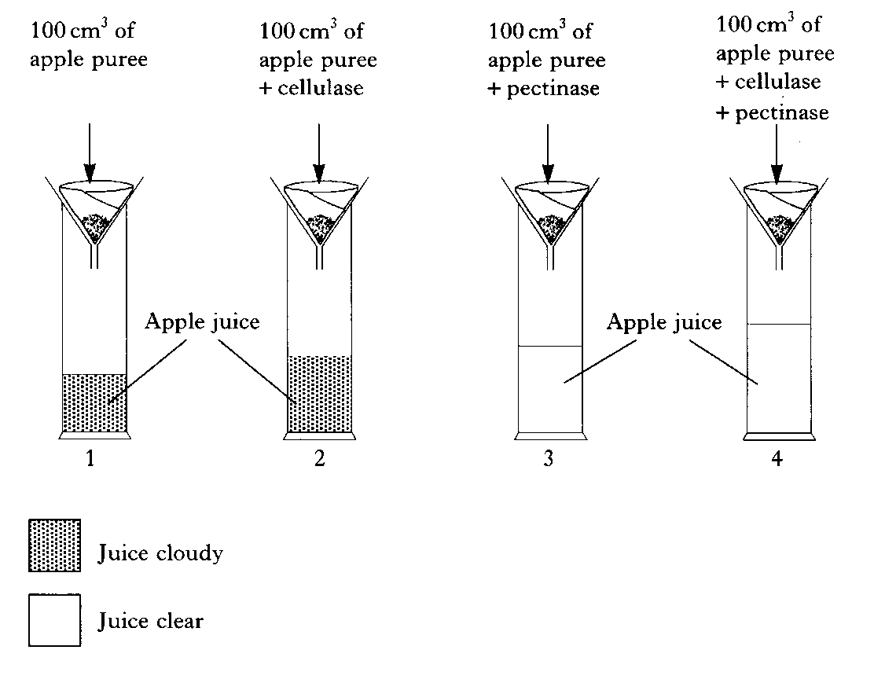The diagram on the left shows the apparatus used and the table shows the results collected.

The investigation was left for 24 hours and then the volume of apple juice in each cylinder measured.

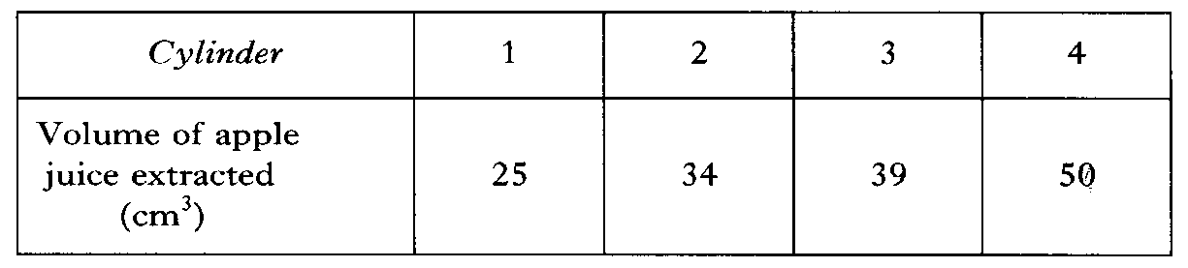

Questions

1. Collect a piece of graph paper and draw a **bar graph** of these results. When your teacher has checked it, stick it into your jotter. [Do you know the success criteria for a bar graph?]

2. Calculate the volume of apple puree required to produce **1000 cm3** of apple juice, if **both** enzymes were used in the extraction. [SHOW YOUR WORKINGS]

3. Predict the effect on the volume of apple juice which would be extracted if the cylinders were placed in a refrigerator at 3 °C for the 24 hours, instead of being kept at room temperature. [CLUE – think about the effect of low temperature on enzyme action]

4. State **two** effects of the addition of pectinase on the extraction of apple juice. [CLUE – compare the results of cylinders 1 and 3]

Update your glossary [](http://www.google.co.uk/url?q=http://www.rhinostationery.com/pack-of-20-rhino-a4-exercise-book-80-page-light-green-f6m/&sa=U&ei=xd4wVYqvOcm2abH0gegL&ved=0CBYQ9QEwAA&usg=AFQjCNFzzM3djH9c-l0kMAFETBmfWvvPAg)

**Enzymes and washing detergent**

[](http://www.clipartpanda.com/clipart_images/vector-chemical-test-tubes-34003632)Enzymes have many uses in industry. One use is in washing detergent where proteases and lipases are added to **digest** stains on clothes.

# **You may be able to try this experiment**

# **Safety**

* 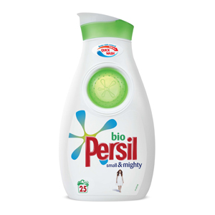Biological washing powders are irritants. They may cause allergic reactions. Avoid contact with skin.

# **Equipment and materials**

* 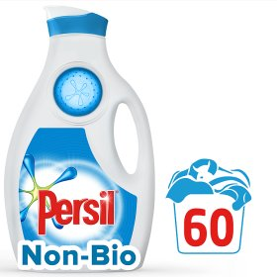three 250 ml beakers
* three 100 cm3 measuring cylinders
* incubator at 30 °C
* cling film
* liquid biological washing detergent / powder solution
* liquid non-biological washing detergent / powder solution
* water
* hard-boiled egg white
* forceps or plastic gloves

# **Method**

1. Label three beakers:
   1. – biological washing detergent
   2. – non-biological washing detergent
   3. – water
2. Measure out 50 cm3 of each of the above using a clean measuring cylinder and place in the correct beaker.
3. Collect three pieces of egg white.
4. Place one piece of egg white into each beaker.
5. Cover the beakers with cling film, and place into an incubator at 30 °C til next lesson.
6. After 2-3 days, record your observations in the table. Compare the cloudiness of the three liquids. A cloudier liquid is evidence of the protein being digested / broken down.

**Results**

Copy and complete the table below.

|  |  |  |  |
| --- | --- | --- | --- |
| **Beaker** | **A Biological detergent** | **B**  **Non-biological detergent** | **C Water** |
| observations |  |  |  |

# **Conclusion**

# Questions

1. State the difference between biological and non-biological washing detergents.
2. Describe the effect of the biological washing detergent on the egg white.
3. Explain why this washing detergent has this effect.
4. How would this be useful in cleaning clothes?
5. Why is the beaker of water included in the experiment?

# Extension

1. Suggest why the beakers needed to be incubated at 30 °C.
2. Explain how you can denature an enzyme, what happens to the enzyme when it denatures and how this would affect the results of the experiment.

You may now be asked to PLAN an investigation to find out the effect of **temperature** on the **stain removal effectiveness** of biological and non-biological detergents.

You must state the

* independent variable and how it will be altered
* dependent variable and how it will be measured
* constant variables and how they will be controlled
* safety precautions

Update your glossary [](http://www.google.co.uk/url?q=http://www.rhinostationery.com/pack-of-20-rhino-a4-exercise-book-80-page-light-green-f6m/&sa=U&ei=xd4wVYqvOcm2abH0gegL&ved=0CBYQ9QEwAA&usg=AFQjCNFzzM3djH9c-l0kMAFETBmfWvvPAg)

**Microorganisms in industry**

 From the S2 Cells unit you may recall how cells respire without oxygen…..fermentation.

Can you remember the equations for fermentation in animal and plant (& yeast) cells?

Look at the pictures below, they may help to jog your memory.

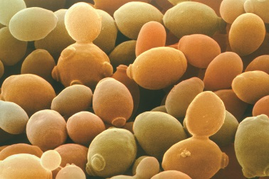

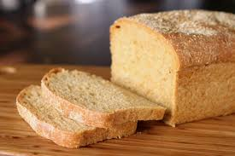

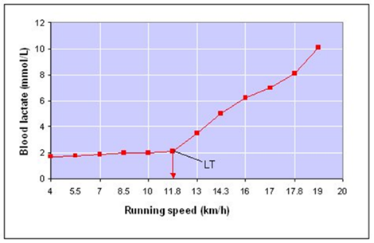

[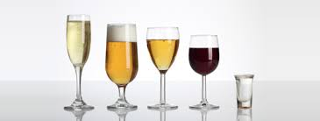](http://www.google.co.uk/imgres?imgurl=http://www.lboro.ac.uk/service/health-wellbeing/images/photos/students/alcohol.jpg&imgrefurl=http://www.lboro.ac.uk/service/health-wellbeing/students/alcohol/&h=200&w=528&tbnid=nRgr6tPon-_79M:&zoom=1&docid=ZlANCunhHwmcsM&ei=F2SQVb2eCMG5Uf_dkKgE&tbm=isch&ved=0CHQQMyg1MDU)

Your teacher may show you the short film about fermentation <https://www.twigonglow.com/film/fermentation-1382/>

**Fermentation in Yeast**

[](http://www.clipartpanda.com/clipart_images/vector-chemical-test-tubes-34003632)

You may have the chance to plan and carry out an investigation into fermentation in yeast.



Update your glossary [](http://www.google.co.uk/url?q=http://www.rhinostationery.com/pack-of-20-rhino-a4-exercise-book-80-page-light-green-f6m/&sa=U&ei=xd4wVYqvOcm2abH0gegL&ved=0CBYQ9QEwAA&usg=AFQjCNFzzM3djH9c-l0kMAFETBmfWvvPAg)

**Bacteria in cheese making**

Your teacher may show you the short film about cheese making <https://www.youtube.com/watch?v=hXhXTs5uwyg>

[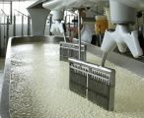](http://biotechlearn.org.nz/focus_stories/cheesemaking/images/curds_and_whey)

[](http://www.mystshopper.com/blog)Cheese making involves **coagulating** (thickening) the milk and then separating the milk into solid **curds** and liquid **whey**. The liquid whey is drained away, and the curds are salted, shaped and left to ripen in a controlled environment.

Microorganisms are used in each step of this process and determine the flavour and texture of the final cheese.

## Bacteria acidify milk

Acidifying (souring) milk helps to separate the curds and whey and control the growth of undesirable [bacteria](http://biotechlearn.org.nz/about_this_site/glossary/bacteria) in cheese. Usually special ‘starter’ bacteria are added to milk to start the cheese making process. These bacteria convert the [**lactose**](http://biotechlearn.org.nz/about_this_site/glossary/lactose) (milk sugar) to **lactic acid** and lower the milk’s **[pH](http://biotechlearn.org.nz/about_this_site/glossary/ph" \o "A measure of the acidity or alkalinity of a substance, based on a scale of 0 to 14. Acidic solutions have pH values less than 7, whereas alkaline solutions have pH values greater than 7.)**.

There are two types of bacteria used for this process:

1. [Mesophilic](http://biotechlearn.org.nz/about_this_site/glossary/mesophilic) bacteria thrive at room temperature but die at higher temperatures. They are used to make mellow cheeses, such as Cheddar, Gouda and Colby.
2. [Thermophilic](http://biotechlearn.org.nz/about_this_site/glossary/thermophilic) bacteria thrive at higher temperatures, around 55 °C, and are used to make sharper cheeses such as Gruyère, Parmesan and Romano.

## Enzymes speed up coagulation

Some cheeses are curdled only by acidity. For example, paneer cheese is made using lemon juice to curdle the milk and cottage cheese is made using mesophilic bacteria. However, for most cheeses, **rennet** (containing an enzyme) is also added to the milk after the starter bacteria. Rennet **speeds up** the coagulation of milk and produces a stronger curd. It also allows curdling at a lower acidity, which is important for some types of cheese.

Update your glossary [](http://www.google.co.uk/url?q=http://www.rhinostationery.com/pack-of-20-rhino-a4-exercise-book-80-page-light-green-f6m/&sa=U&ei=xd4wVYqvOcm2abH0gegL&ved=0CBYQ9QEwAA&usg=AFQjCNFzzM3djH9c-l0kMAFETBmfWvvPAg)

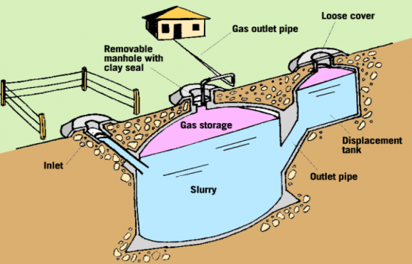**Microorganisms in biofuel production**

Wastes can be converted into useful **fuels** by the action of microorganisms. There are two examples below.

**Biogas**

The film shows the impact of dung based **biogas** plants on women in South India. <http://www.youtube.com/watch?v=pdsSyOXj3ss>

[](http://www.google.co.uk/url?q=http://www.rhinostationery.com/pack-of-20-rhino-a4-exercise-book-80-page-light-green-f6m/&sa=U&ei=xd4wVYqvOcm2abH0gegL&ved=0CBYQ9QEwAA&usg=AFQjCNFzzM3djH9c-l0kMAFETBmfWvvPAg) Answer the following questions in your jotter

* 1. What three problems are caused by the smoke from wood burning fires?
  2. What problems are caused by using wood as a fuel?
  3. What fuel is added to the biogas tank?
  4. What gas is produced in the tank?
  5. How does this gas help the women in the kitchen?
  6. What useful substance is made from the slurry in the tank?
  7. How does this substance help the women?

Use the internet to find out about **Ethanol** fuel in Brazil

(good information on Wikipedia).

1. What is the raw material from which ethanol is made?
2. What biological process turns the raw material into ethanol?
3. What did the Brazilian government decide in 1976?
4. What do you think is the main advantage of using ethanol as fuel to replace petrol?
5. What has happened to production of ethanol since 2010 and why?

You may have time to watch the short video –

Imagine a Future with Sugarcane <https://www.youtube.com/watch?v=4aVlV_GLJek>

Update your glossary [](http://www.google.co.uk/url?q=http://www.rhinostationery.com/pack-of-20-rhino-a4-exercise-book-80-page-light-green-f6m/&sa=U&ei=xd4wVYqvOcm2abH0gegL&ved=0CBYQ9QEwAA&usg=AFQjCNFzzM3djH9c-l0kMAFETBmfWvvPAg)

**Stems Cells** Your teacher will show you a presentation and you will take part in two activities to help you understand what stem cells are.

**Stem Cell Decisions Activity** (in groups of 4)

Aim – to find out what stem cells do.

Collect – For each person

* A decision maker
* 2 blood stem cells each

-For the group to share

* about 16 spare stem cells
* a pot for red blood cells and a pot for white blood cells
* dice

How to play

* 1. Start with two blood stem cells and one decision maker each
  2. You need to make some red blood cells and white blood cells, but YOU CAN ONLY KEEP PLAYING IF YOU HAVE A BLOOD STEM CELL.
  3. Player 1 rolls the dice, open and close the decision maker the number of times shown on the dice
  4. Ask the person next to you to choose a number between 1-4. Open the flap with that number on it.
  5. If you find a stem cell picture, take another blood stem cell. If you find a different kind of cell, put your token in the cup with that type of cell on it.
  6. Repeat steps 3-5 for the next player.
  7. Play until everyone has run out of stem cells.

Now answer the questions below in FULL SENTENECES. [](http://www.google.co.uk/url?q=http://www.rhinostationery.com/pack-of-20-rhino-a4-exercise-book-80-page-light-green-f6m/&sa=U&ei=xd4wVYqvOcm2abH0gegL&ved=0CBYQ9QEwAA&usg=AFQjCNFzzM3djH9c-l0kMAFETBmfWvvPAg)

* What two different things can the blood stem cells do?
* What happened when you ran out of stem cells? What do you think would happen if your body ran out of stem cells?

**Tissue Stem Cells**

**Stem Cell Families Card Game** (in groups of 3 or 4)

Aim – To find out about the different types of Tissue stem cell in the body.

In the game, you are trying to collect as many families of stem cells as you can, each family has four members – 1 stem cell and 3 specialised cells.

* 1. shuffle the cards and deal them face down
  2. each player looks at their cards and decide which family to collect
  3. The player to the left of the dealer starts: Chose a card you don’t want. Give it to the person on your left, without letting anyone else see it.
  4. Now the person who has received the card can play: If you have 4 cards of the same family, put them down on the table for everyone to see. Now chose a card to pass to the person on your left.
  5. Continue until all the cards are used up. (Or until told to stop)
  6. Place the sets of family cards on the body diagram
  7. Which set does not fit on the body diagram? Why?

These resources are from <http://www.eurostemcell.org/>

Visit this website to find out much more about Stem Cells.

Your teacher may have time to show you the **Stem Cell Story** film.

<http://www.eurostemcell.org/stem-cell-story>. In this film, you will see some applications of stem cell technology. One successful application of stem cell technology is in the growth of new skin for burns victims. You may be shown these additional short videos in class.

More uses of Stem Cells

<https://www.twigonglow.com/film/stem-cells-1065/> [3min13]

<https://www.twigonglow.com/film/therapeutic-stem-cells-1066/> [3min26]

Make notes in your jotter about some of the applications of stem cell technology. Update your glossary [](http://www.google.co.uk/url?q=http://www.rhinostationery.com/pack-of-20-rhino-a4-exercise-book-80-page-light-green-f6m/&sa=U&ei=xd4wVYqvOcm2abH0gegL&ved=0CBYQ9QEwAA&usg=AFQjCNFzzM3djH9c-l0kMAFETBmfWvvPAg)

**TIME TO DO SOME REVISION….**

* Update your glossary

[](http://www.google.co.uk/url?q=http://findicons.com/icon/24960/highlighter_yellow_01&sa=U&ei=xOcwVaCqItjiasHygagE&ved=0CDwQ9QEwEg&usg=AFQjCNFpsXWVQOg-ovDcvsZA0dSkJYiktg)

* Highlight the key words in your Learning Outcome Checklist.

[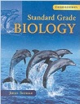](http://www.google.co.uk/url?sa=i&rct=j&q=&esrc=s&frm=1&source=images&cd=&cad=rja&uact=8&ved=0ahUKEwjApdCIh73JAhXH7RQKHdceA84QjRwIBw&url=http://www.amazon.co.uk/Standard-Grade-Biology-3rd-Edn/dp/0340789573&psig=AFQjCNF08aofxcZSOMfcddt6C2bP5u6NNA&ust=1449141528751522)

* Use the Standard Grade Biology Text Book

[Third Edition] Chapter7

* [](http://www.google.co.uk/url?sa=i&rct=j&q=&esrc=s&frm=1&source=images&cd=&cad=rja&uact=8&ved=0ahUKEwjS-5S_h73JAhXDtxoKHaUTBdsQjRwIBw&url=http://www.gbt.literaryconnections.co.uk/&psig=AFQjCNHB-qzRVXnJMTfckFhYAQrHj4q3fw&ust=1449141653388786)Test Question Practice Booklet available. Complete as many of these as possible. Remember to **mark your answers** and follow up any errors with extra revision.

Also try the following activities.

* Glossary Flashcards available at <http://www.hns.org.uk/bio/>
* Biotechnology TABOO-PICTIONARY Revision game