N5 CB6 Respiration HW [GRAPH PAPER NEEDED]
PART ONE
1.
For each statement below decide if it TRUE or FALSE.
If TRUE, write True. If FLASE, write False AND the word to replace the underlined word to make the statement TRUE.
a) Oxygen is always required in fermentation.
b) Plant cells produce ethanol and CO₂ in fermentation.
c) The first stage of aerobic respiration produces less ATP than the second stage.
d) Aerobic respiration takes place in the cytoplasm and the ribosome. [4]

2. Name 3 cell processes that require ATP. [3]
3. An experiment was carried out to investigate the heat production of 3 organisms. Each organism was enclosed in an insulated, ventilated glass box and left for one hour. The temperatures are shown in the table:
 | Temperature (ºC)
Organism | 0 mins  (Start) | 15mins | 30mins | 45mins | 60mins | Total rise in temperature
Mouse | 20.0 | 22.5 | 26.0 | 29.5 | 32. 0 | A
Woodlouse | 21.0 | 21.5 | 22.0 | 22.5 | 23.0 | B

(a) Calculate the simple whole number ratio of total temperature rise in a mouse to a woodlouse. [1]

(b) Calculate the average temperature rise per minute of the mouse. [1]

(c) Why is it important to compare the total rise in temperature for each organism rather than just comparing the final temperature at 60mins? [1]

(d) Why must the box containing the organisms be insulated? [1]

(e) How could you improve the reliability of this experiment? [1]

(f) The student carrying out the experiment decided to measure the rate of respiration of each organism. Name the apparatus they would use. [1]

(g) Draw a line graph (2 lines on the same line graph) to show the information in the table. [3]
4. The diagram below shows part of an investigation into the effect of adding three
different concentrations of ATP solution to three pieces of muscle. When muscle contracts it decreases in length.

Equal volumes of the ATP solutions were added to the pieces of muscle.
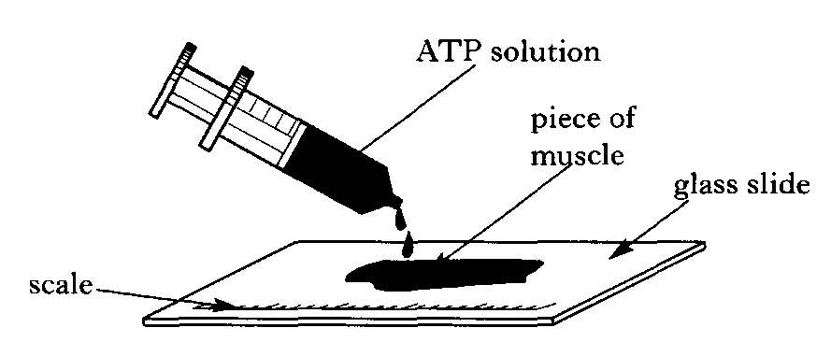
The results are shown in the following table.

 | Length of muscle
Concentration  of ATP solution  (g per litre) | At start  (mm) | After 10  Minutes  (mm) | Decrease  (mm) | Percentage decrease
1 | 35 |  | 0∙7 | 2
5 | 50 |  |  | 8
10 | 40 | 33 | 7

a) (i) For the muscle that had 1 g per litre ATP added, calculate the length of the muscle after 10 minutes. [1]
ii) For the muscle that had 5g per litre ATP added, calculate the decrease in length and the length after 10 minutes. [1]
iii) Calculate the percentage decrease in length of the muscle with 10 g per litre ATP solution. [1]
(b) Explain why three different syringes should be used in this investigation. [1]
(c) Describe a suitable control for this experiment. [1]
TOTAL 21
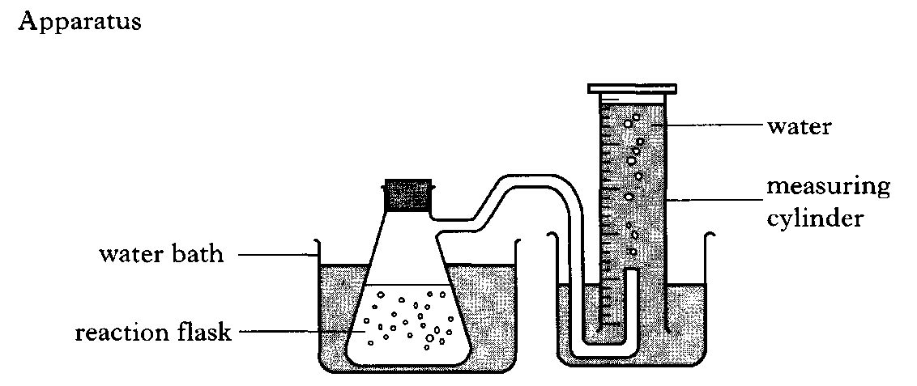
PART TWO [GRAPH PAPER NEEDED]
5. An investigation was carried out into the effect of temperature on the rate of respiration by yeast. Details of the apparatus, method used, and results are given on the right and below.
Method
1. Water baths were set up over a range of temperatures.
2. Glucose solution and yeast suspension were allowed to reach the same temperature as the water bath.
3. The glucose solution and the yeast suspension were mixed in the reaction flask.
4. After 1 hour, the volume of gas in the measuring cylinder was measured.
Temperature (°C) | 10 | 20 | 30 | 40 | 50
Volume of gas produced in 1 hour (cm³) | 9 | 18 | 36 | 48 | 5

Results

(a) Describe the relationship between the temperature and the volume of gas produced in one hour. [2]
(b) Predict the volume of gas which would be collected in one hour if the investigation was repeated at 60°C. Explain your answer. [2]
(c) Describe the control flasks that would be set up to show that the gas was produced due to activity of the yeast and to no other factor. [2]
(d) Other than time allowed for the reaction to take place, give two variables that should have been kept constant to ensure a valid experiment. [2]
(e) How many times greater is the Volume of gas produced in 1 hour at 30°C to that produced at 10°C? SHOW YOUR WORKING [1]
(f) Use the results to draw a line graph to show the volumes of gas produced in one hour over the range of temperatures. WHEN DONE, CHECK YOUR ANSWER TO Q (a) [3]
TOTAL 12

