N5 Biology CB2 Homework

- Use your own words to describe the structure and properties of the cell membrane. In your description make sure you include the terms: bilayer, protein, phospholipid and selectively permeable [4]

2. An experiment was set up to investigate the composition of the cell membrane. State the TWO experiments should be compared to investigate the effect of alcohol on the membrane and explain your choice. [2]
beetroot
20˚C
alcohol
carrot
20˚C
water
carrot
20˚C
alcohol
beetroot
40˚CC
water
A
B
C
D
3. Copy and complete the table to compare diffusion and active transport:
 | Diffusion | Active Transport
1. Example of substance that moves through cell membrane by this process:
2. Do particles move from high to low or low to high concentration?
3. Do particles move down or against a concentration gradient?
4. Is energy required?
5. Is the process passive?
[10]
4. Give the full definition of osmosis. [3]
5. The diagrams show the appearance of flower petal cells before and after being placed in solution X.
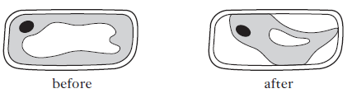
- What name is used to describe the appearance of the cells:
    - before being placed in solution X?
    - after being placed in solution X?
[2]
- Describe solution X? [2]
- How could you return the cells to their appearance before? [1]

turnip disc | Solution | Final Mass (g) | Change in Mass (g) | % Change in Mass
1 | Water | 3.10
2 | 5% Salt | 2.05
3 | 10% Salt | 1.40
- Turnip discs (each weighing 2.00g) were placed in 3 different solutions for 24 hours and then reweighed. The results are shown in the table:

- Copy and complete the table. [3]
- Explain the change in mass for turnip disc 1. [2]
- Which solution is closest to the concentration of salt in the turnip cells? Explain your answer. [2]
- How could the results be made more reliable? [1]

[Total = 30 marks]

